

What is the relationship between the amount of time spent trick-or-treating and the amount of candy a person gets? Here are data from students from last year.

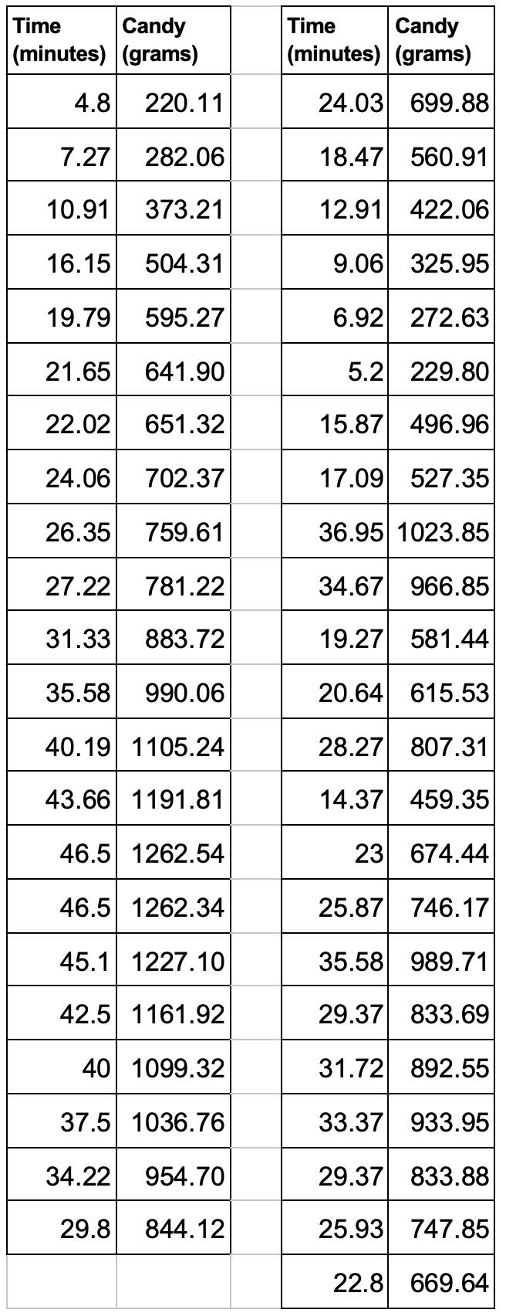

**1.Input the values into your calculator with time in L1 and candy in L2.**

(STAT/EDIT/Edit)

**2. Make a scatterplot**

(2nd / Y = / Xlist: L1, Ylist: L2 / Zoom / 9: ZoomStat).

**3. Describe the relationship.**

**4. Find the equation of the LSRL.** (STAT / CALC / 8:LinReg(a+bx) )

**5. Find and interpret the residual for the student who spent 23 minutes trick-or-treating.**

**6. Create a residual plot.** (2nd / Y = / Xlist: L1, Ylist: RESID / Zoom / 9: ZoomStat)

7. **Is a linear model appropriate for this data?**

**Use your residual plot to justify.**