
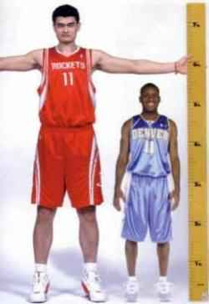
Where Do I Stand?
How does my height compare with other AP Stats students?

The dotplot below represents a random sample of the heights of 20 AP Stats students.

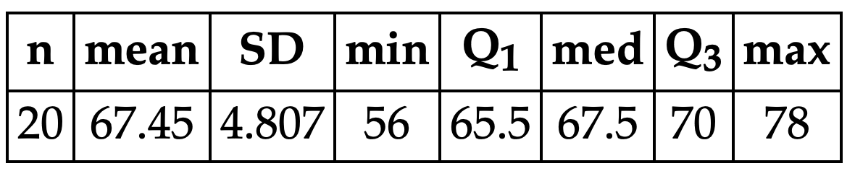
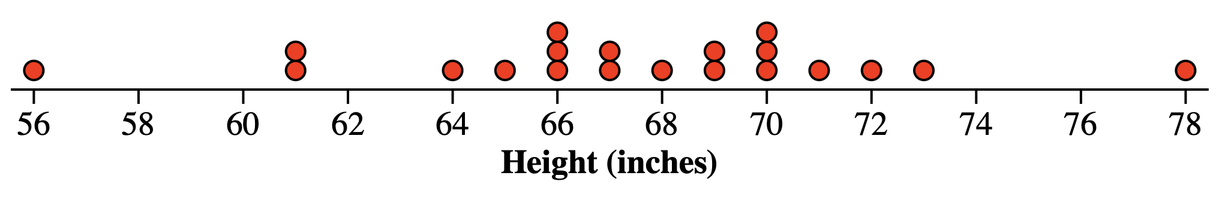

- Describe the distribution.

- a. Arianna is 65 inches tall. What percent of the heights are less than or equal to 65?
b. What is your height? What percent of the heights are less than or equal to your height?
Height | Frequency | Relative  Frequency (%) | Cumulative  Relative Freq. (%)
56-60
61-65
66-70
71-75
76-80
- Complete the table.

- Use the values in the table to create a cumulative relative frequency graph.
- Mrs. Gallas is 66 inches tall. Estimate and interpret her cumulative relative frequency.
Cumulative Relative Frequency

- Estimate and interpret the height that has 60% cumulative relative frequency.
Height (in)
Lesson 2.1 – Percentile
QuickNotes:
Check Your Understanding:

- According to a recent article at Insider.com, the state of Pennsylvania was at the 82nd percentile for Pre-K to 12th grade education rating and was at the 2nd percentile for higher education rating. Explain what these values mean.

- The graph displays the cumulative relative frequency of the average cost of in-state public college tuition for each of the 50 states.

- About what percent of states have in-state public college tuition less than or equal to $8000? More than $8000?

- Estimate Q₁, Q₃, and the IQR of the distribution of in-state public tuition.

