**Why Do Some Schools Do Better Than Others?**



Academic performance of students varies widely from one school to another. What are some of the reasons? How can public education improve outcomes for all students?

A random sample of 11 high schools was selected from the state of Michigan and data was recorded for two variables. In Michigan, all high school Juniors are required to take the SAT.

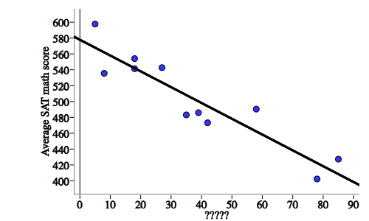

1. The variable on the y-axis is "Average SAT math score". What variable is on the x-axis? Brainstorm several ideas in your groups.

2. Your teacher will reveal the variable on the x-axis. Write it in on the above scatterplot.

3. Describe the relationship between *x* and *y*.

4. Can we conclude that being poor causes student achievement to decrease? Explain.

5. What might be some confounding variables that would help explain this relationship?

6. The equation of the line of best fit is . Use it to predict the average SAT math score for a high school with 58% of students free/reduced lunch.

7. East Kentwood High School (home of The Stats Medics!) is represented in the data set with 58% free/reduced lunch and an average SAT math score of 490.4. Calculate and interpret the residual for East Kentwood High School. ()

8. We are working hard in public education to eliminate this very clear relationship that currently exists between poverty and academic achievement. What is your school currently doing to eliminate this inequity? What else could they do?

*Education must enable one to sift and weigh evidence, to discern the true from the false, the real from the unreal, and the facts from the fiction. The function of education, therefore, is to teach one to think intensively and to think critically. Intelligence plus character--that is the goal of true education. – Martin Luther King Jr.*