2024 AP Statistics Exam #1
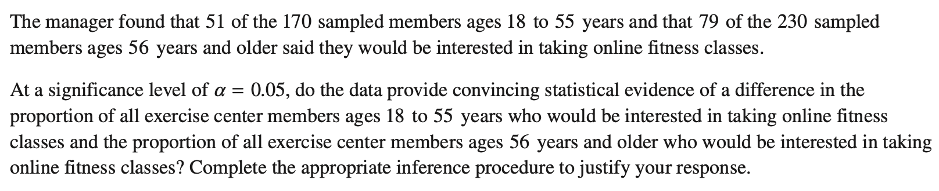
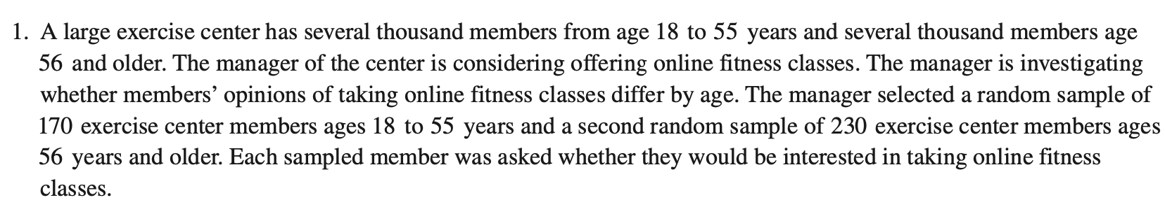
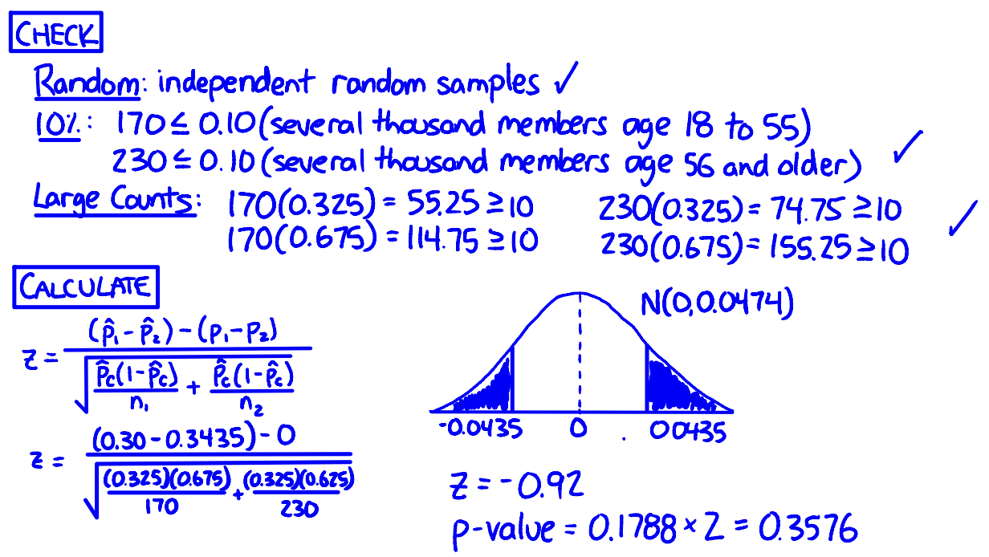
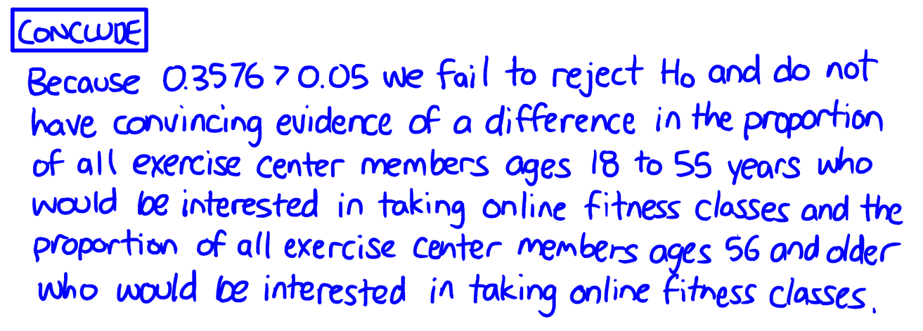
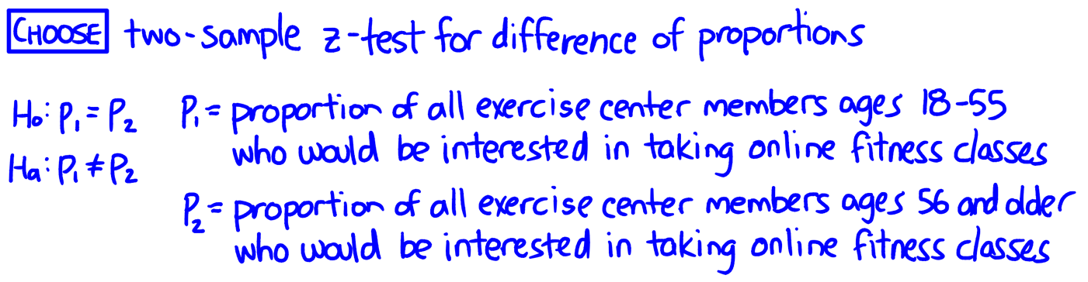
QuickNotes
- Identify procedure
- Correct hypotheses
- Context
2024 #1 - Section 1

Student response #1

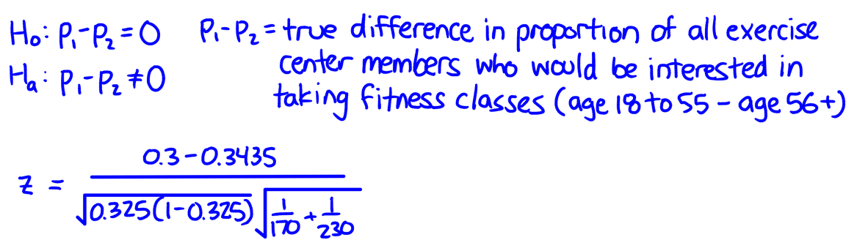
Component 1?

Component 2?

Component 3?

E, P, or I?

Student response #2

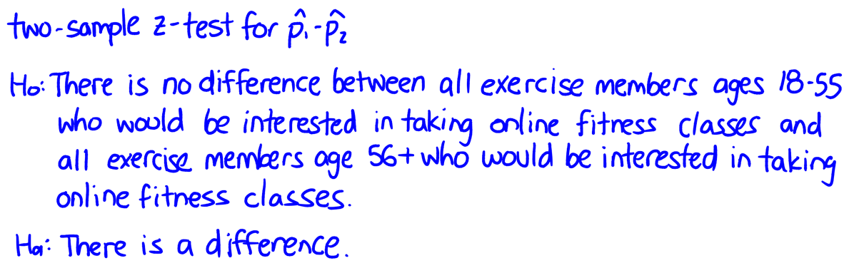
Component 1?

Component 2?

Component 3?

E, P, or I?

Student response #3

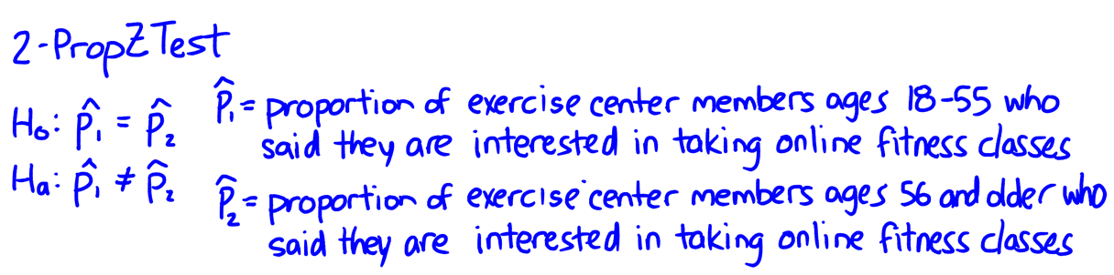
Component 1?

Component 2?

Component 3?

E, P, or I?

QuickNotes
- Independence condition
- Large Counts condition
- Correct z-statistic
- Correct p-value
2024 #1 - Section 2

Student response #1
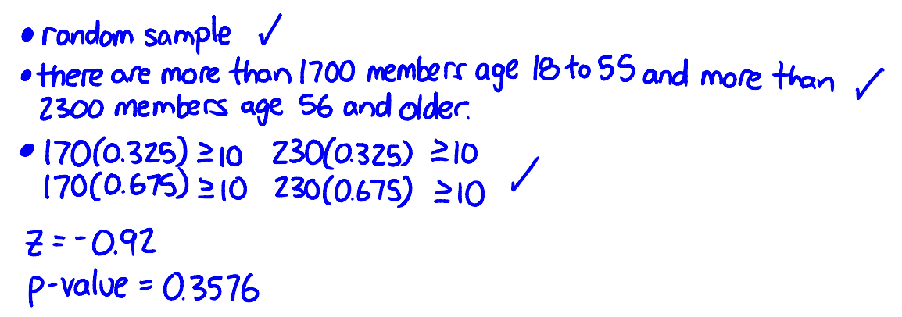
Component 1?

Component 2?

Component 3?

Component 4?

E, P, or I?

Student response #2

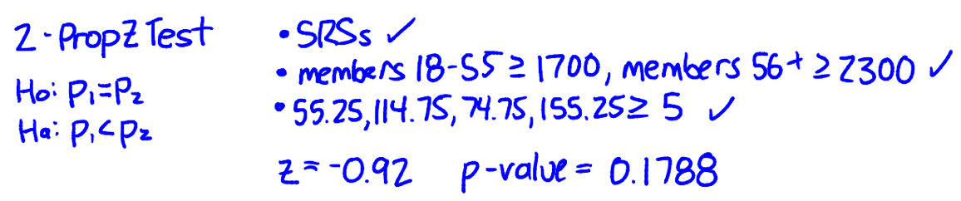
Component 1?

Component 2?

Component 3?

Component 4?

E, P, or I?

Student response #3

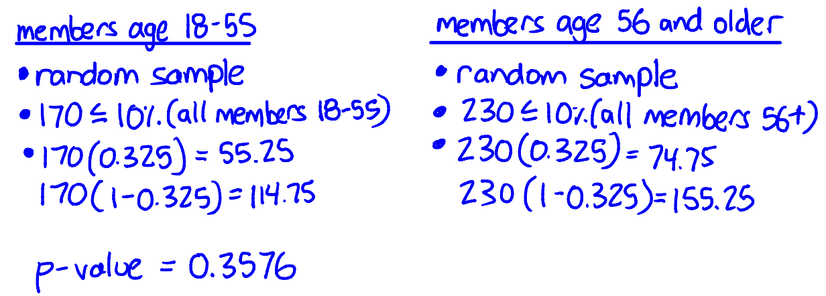
Component 1?

Component 2?

Component 3?

Component 4?

E, P, or I?
QuickNotes
- Linkage + decision
- Conclusion in context
2024 #1 - Section 3

Student response #1


Component 1?

Component 2?

E, P, or I?

Student response #2
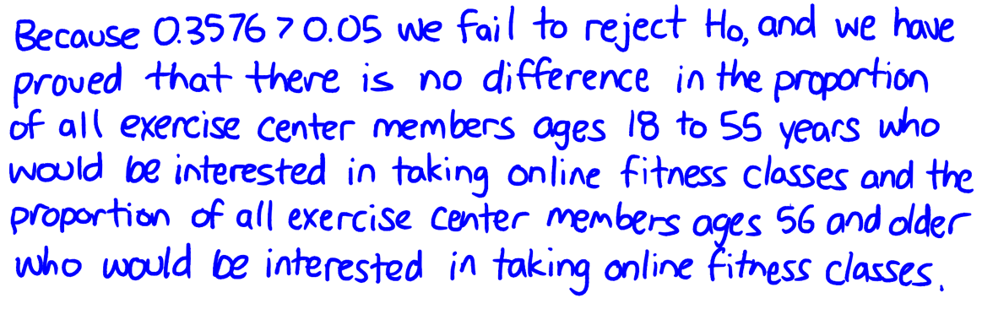
Component 1?

Component 2?

E, P, or I?

Student response #3
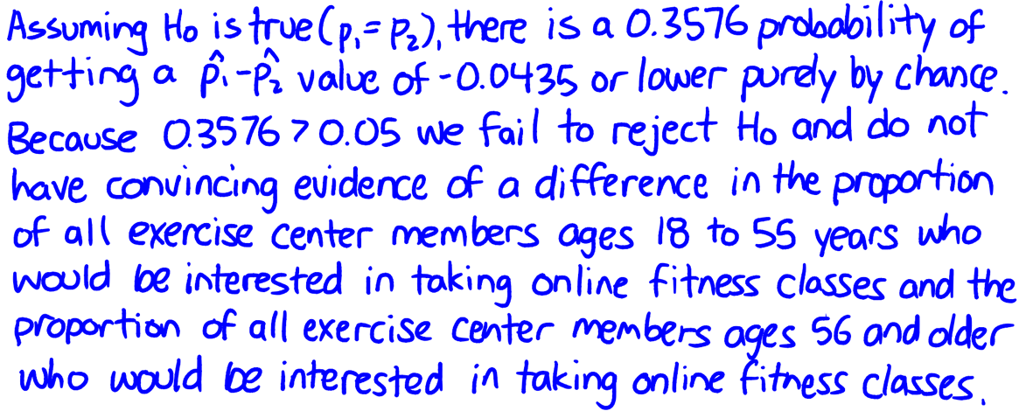
Component 1?

Component 2?

E, P, or I?

