**How Much Do Fans Love Justin Timberlake? Day 2**

In the next city, Justin Timberlake’s concert promoter again wants to find out how much fans enjoy his concerts. He will ask fans, “From 1 to 100, where 100 is the most, how much did you enjoy the concert?” Again, he wants to take a sample of 10 fans. He also would like to try out a couple of new methods for sampling.

1. 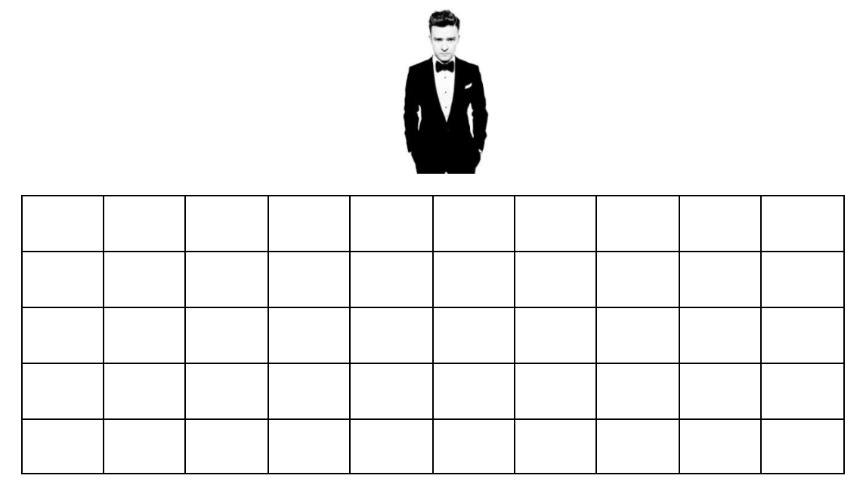**Method #1**:

Take a simple random sample (SRS) of 10

fans.

1. **Method #2:**

Yesterday we decided the row would have a big impact their enjoyment. The promoter decides to sample **entire columns** (sample every fan in the selected columns).

* 1. Why would sampling all the fans in a column give a good estimate?
  2. How many columns will the promoter need to select to get a sample of 10 fans? Randomly choose the columns and mark the fans that will be sampled.

1. **Method #3:**

Justin’s manager thinks it is important to sample fans that have different views of the stage. He wants to sample every 7th fan.

* 1. First, we need to figure out the starting fan. Randomly select a fan and mark with an X.
  2. Begin marking every 7th seat until you get a sample of 10 seats (start back at the beginning if you need to).

1. Which method do you think is best? Why?

1. Now, it’s time for the actual data. For each of your samples on the previous page, calculate the average enjoyment. Add your average to the dotplots on the board.

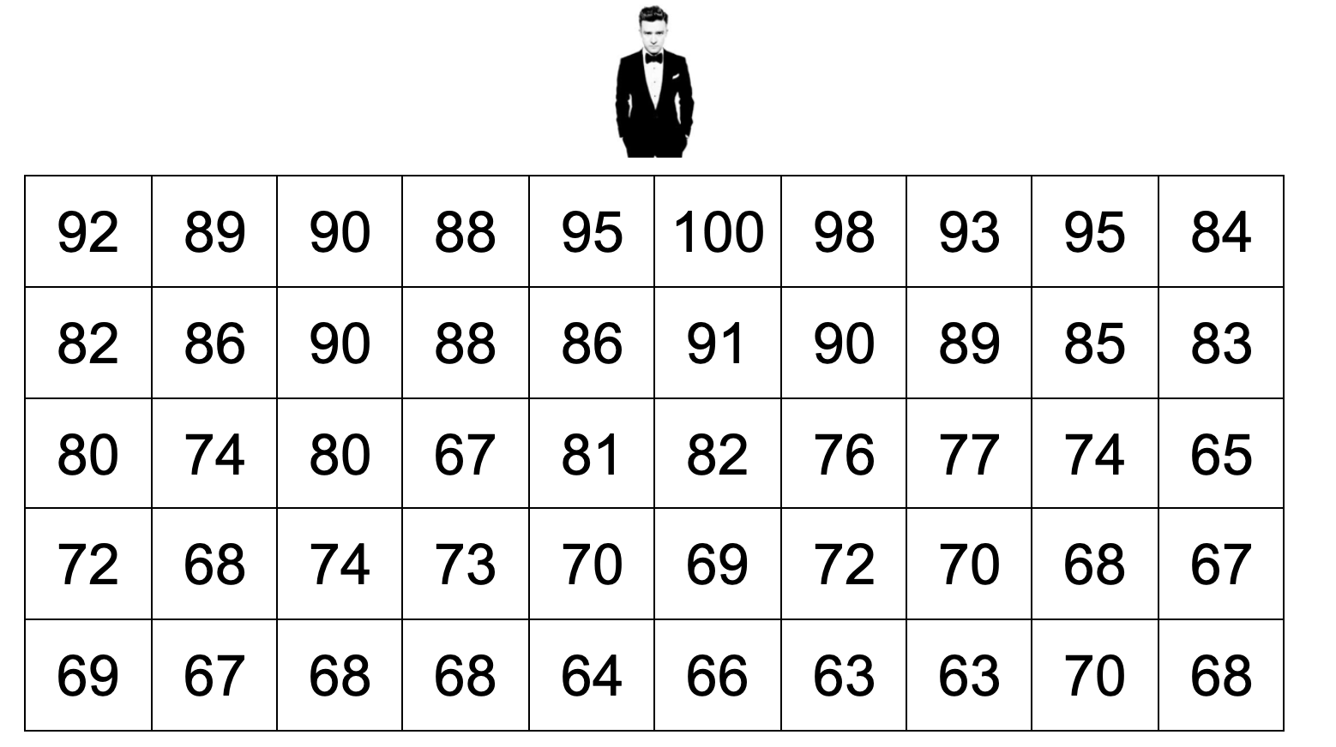

Sample #1:

Sample #2:

Sample #3:

**Method #1: SRS**

 average enjoyment

**Method #2: Cluster Sample**

 average enjoyment

**Method #3: Systematic Random Sample**

 average enjoyment

More Random Sampling Methods Day 2

Important Ideas:

Check Your Understanding:

A large hospital would like to survey their patients on their level of satisfaction with their hospital room. The hospital has 10 floors, each with 15 rooms (total of 150 rooms). The hospital staff would like to take a sample of 30 rooms.

1. Describe how to select a stratified random sample of 30 rooms.
2. Describe how to select a cluster sample of 30 rooms.
3. Describe how to select a systematic random sample of 30 rooms.
4. Explain a benefit of using each of the three types of sampling methods in this context.