Gimme 10

- Let $g\left(x\right)=-5x^{6}-8x^{5}+11x^{3}-22x+1$. Which of the following statements describes the end behavior of $g$?

- $\lim_{x→∞}{g(x)}=∞$ and $\lim_{x→-∞}{g(x)}=∞$
- $\lim_{x→∞}{g(x)}=∞$ and $\lim_{x→-∞}{g(x)}=-∞$
- $\lim_{x→∞}{g(x)}=-∞$ and $\lim_{x→-∞}{g(x)}=∞$
- $\lim_{x→∞}{g(x)}=-∞$ and $\lim_{x→-∞}{g(x)}=-∞$

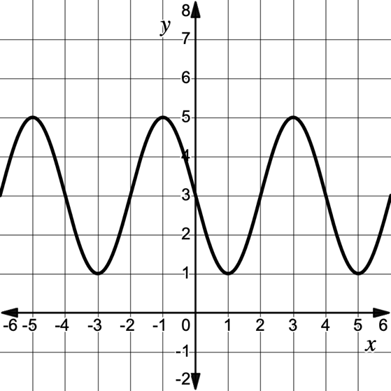
- The sinusoidal function shown can be modeled by the function $f\left(x\right)=a cos\left(b\left(x-c\right)\right)+d$ for some constants $a, b, c,$ and $d$. Find the value of $b$.

- $b=\frac{π}{2}$
- $b=\frac{π}{4}$
- $b=2$
- $b=4$

- The graph of a quintic (5th degree) function, $f$, is tangent to the $x$-axis at $x=3$. Which of the following could describe the zeros of $f$?

- 1 real zero, 4 imaginary zeros
- 2 real zeros, 0 imaginary zeros
- 3 real zeros, 2 imaginary zeros
- 2 real zeros, 3 imaginary zeros

- Angle $α$ is shown in standard position, with terminal ray passing through Point P.
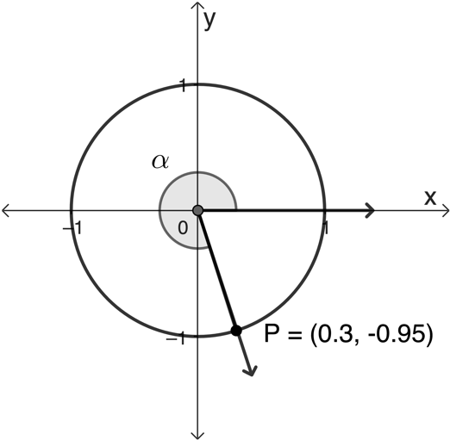
Find $\tan{(-α)}.$

- $-\frac{0.95}{0.3}$
- $\frac{0.95}{0.3}$
- $\frac{0.3}{0.95}$
- $-\frac{0.3}{0.95}$

- The average U.S. resident produces about 4.5 pounds of trash per day, which equates to 1,642 pounds of trash annually. Suppose an individual was motivated to reduce their trash production by 10% each year. Which of the following equations could be used to model the daily number of pounds of trash produced by the individual, $t(d)$, after $d$ days?

- $t\left(d\right)=1642{\left(0.90\right)}^{d}$
- $t\left(d\right)=4.5{\left(0.90\right)}^{\frac{d}{365}}$
- $t\left(d\right)=1642{\left(0.90\right)}^{365d}$
- $t\left(d\right)=4.5{\left(\frac{0.90}{365}\right)}^{365d}$

- If $f\left(x\right)=2x+1$ and $g\left(f\left(x\right)\right)=\sqrt{2x+2}$, what is the equation for $g(x)$?

- $g\left(x\right)=\sqrt{2x+1}$
- $g\left(x\right)=2x+2$
- $g\left(x\right)=\sqrt{x+1}$
- $g\left(x\right)=\sqrt{x}$

- The graphs of two quadratic functions $f$ and $g$ are shown. The solid curve represents $f$ and the dashed curve represents $g$. Let $h\left(x\right)=\frac{g\left(x\right)}{f\left(x\right)}$. Which of the following statements is true?
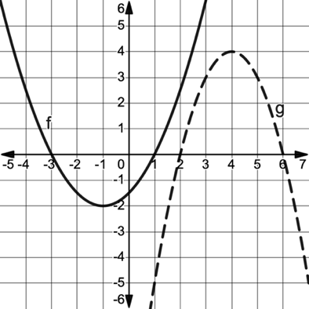
- As $x$ increases without bound, $h(x)$ decreases without bound.
- The graph of $h$ has vertical asymptotes at $x=2$ and $x=6$.
- The graph of $h$ has $x$-intercepts at $x=-3, x=1, x=2,$ and $x=6$.
- The domain of $h$ is all real numbers where $x≠-3$ and $x≠1$.

- The table gives values of a logarithmic function $f$ for selected values of $x$.

$$x$$ | 1 | 3 | 9 | 27 | 81 | 243
$$f(x)$$ | 0 | 7 | 14 | 21 | 28 | 35

Which of the following could be the equation for $y=f^{-1}(x)$?

- $f^{-1}\left(x\right)=7\log_{3}{x}$
- $f^{-1}\left(x\right)=1+\frac{2}{7}x$
- $f^{-1}\left(x\right)=3^{\frac{x}{7}}$
- $f^{-1}\left(x\right)=\frac{1}{7}⋅3^{x}$

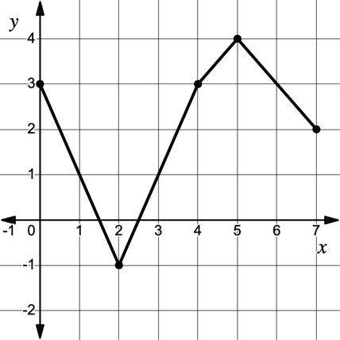
- The complete graph of $y=h(x)$ is shown below. What is the range of $-3h\left(x\right)+2$?

- $[-10, 5]$
- $[-1, 14]$
- $[-18, -3]$
- $[-19,2]$

- Consider the polar function $r=f\left(θ\right)=9\sin{(3θ)}$. On the interval $\frac{π}{3}<θ<\frac{π}{2}$, which of the following statements is true?

- $r$ is increasing and the distance between a point on the curve, $\left(θ, f\left(θ\right)\right)$, and the origin is increasing.
- $r$ is decreasing and the distance between a point on the curve, $\left(θ, f\left(θ\right)\right),$ and the origin is increasing.
- $r$ is increasing and the distance between a point on the curve, $\left(θ, f\left(θ\right)\right),$ and the origin is decreasing.
- $r$ is decreasing and the distance between a point on the curve, $\left(θ, f\left(θ\right)\right),$ and the origin is decreasing.

