

How Many Canoes Are Available?
A canoe rental livery rents out canoes to customers to use on a nearby river. The livery has 80 canoes available. The rate of change of the number of canoes available at the livery on a Saturday can be modeled by the function $R$ for $0≤t≤11$, where $R(t)$ is measured in canoes per hour, and $t$ is measured in hours since the livery opened. The graph of $R$ is shown.
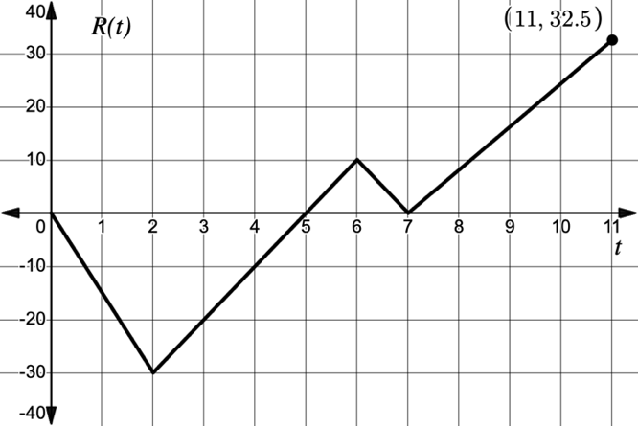

- What does it mean in this context if $R(t)$ is below the $t$-axis?

- What does it mean in this context if $R(t)$ is above the $t$-axis?

- The function $C$ is defined as $C\left(x\right)=80+\int_{0}^{x}{R(t)}dt$.
  - Find $C(0)$. Interpret your answer in the context of this problem.

  - Find $C(6)$. Interpret your answer in the context of this problem.

- Write an equation for $C'(x)$ and find $C'(2)$. Interpet your answer in context.

- When is the number of canoes available decreasing? How do you know?

- When is the number of canoes available at a minimum? Justify your answer.

- When is the number of canoes available increasing at a decreasing rate? Justify your answer.
Lesson 6.6 – Justifying Behavior of Accumulation Functions
QuickNotes

Check Your Understanding
- Let $f$ be a function defined for $-6≤x≤6$. The graph of $f$ is shown. Let $h\left(x\right)=\int_{-4}^{x}{f\left(t\right)dt}$.
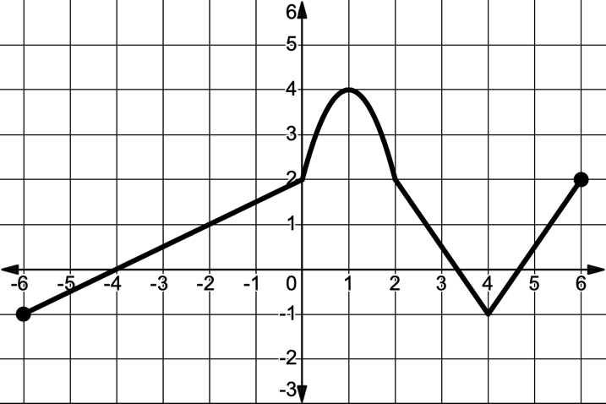
  - Find $h\left(-2\right), h^{'}\left(-2\right),$ and $h''(-2)$.

  - Find all values of $x$ on the open interval $-6<x<6$ where $h$ has a relative minimum. Justify your answer.

  - On which interval(s) is the graph of $h$ concave up? Justify your answer.

  - For which values of $x$ does $h$ have a point of inflection? Justify your answer.

  - For which value of $x$ does the graph of $y=h''(x)$ have an $x$-intercept? Explain.

