** Can You Taco Tongue and Evil Eyebrow? Day 1**

Some people believe that the ability to taco tongue and evil eyebrow is something that you are born with. Is this true? Are the two abilities somehow related?

1. Collect class data to fill in the following two-way table and Venn Diagram.

Yes

Taco Tongue

_____

_____

_____

_____

Yes

Evil Eyebrow

|  |  |  |  |
| --- | --- | --- | --- |
|  | Yes  Evil Eyebrow | No  Evil Eyebrow | Total |
| Yes Taco Tongue |  |  |  |
| No Taco Tongue |  |  |  |
| Total |  |  |  |

1. Suppose that we randomly choose a student from class. Find the following probabilities.

P(Yes Taco Tongue) = P(Yes Evil Eyebrow) =

P(No Taco Tongue) = P(No Evil Eyebrow) =

P(Yes Taco Tongue AND Yes Evil Eyebrow) = P(Yes Evil Eyebrow AND No Taco Tongue) =

P(Yes Taco Tongue AND No Evil Eyebrow) = P(No Taco Tongue AND No Evil Eyebrow) =

1. Suppose that we randomly choose a student from class. Find the following probabilities.

P(Yes Evil Eyebrow) =

P(No Evil Eyebrow) =

P(Yes Evil Eyebrow OR No Evil Eyebrow) =

1. Suppose that we randomly choose a student from class. Find the following probabilities.

P(Yes Taco Tongue) =

P(Yes Evil Eyebrow) =

P(Yes Taco Tongue OR Yes Evil Eyebrow) =

Venn Diagrams and the General Addition Rule

Important Ideas:

Check Your Understanding:

What is the relationship between educational achievement and home ownership? A random sample of 500 U.S. adults was selected. Each member of the sample was identified as a high school graduate (or not) and as a homeowner (or not). The two-way table displays the data. Suppose we choose a member of the sample at random. Define events

G: person is a high school graduate H: person is a homeowner.

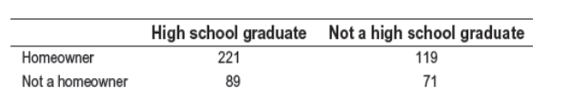

1. Explain in plain language what *P*(Gc) means and find the probability.

2. Explain why *P*(G or H) ≠ *P*(G) + *P*(H). Then find *P*(G or H).

3. Make a Venn diagram to the right to display the sample space of this chance process.

4. Write the event “is not a high school graduate and is a homeowner” in symbolic form and find the probability.