Offense or Defense?

Let’s look at offensive and defensive statistics for National Football League teams from the 2021 season, shown in the table below. What variable does a better job at predicting a team’s winning percentage (PCT): the number of points an offense scores (PF = points for) or the number of points a defense allows (PA = points against)?

Team | 49ers | Bears | Bengals | Bills | Broncos | Browns | Buccaneers | Cardinals | Chargers | Chiefs | Colts | Cowboys | Dolphins | Eagles | Falcons | Football Team | Giants
PF | 427 | 311 | 460 | 483 | 335 | 349 | 511 | 449 | 474 | 480 | 451 | 530 | 341 | 444 | 313 | 335 | 258
PA | 365 | 407 | 376 | 289 | 322 | 371 | 353 | 366 | 459 | 364 | 365 | 358 | 373 | 385 | 459 | 434 | 416
PCT | 59 | 35 | 59 | 65 | 41 | 47 | 77 | 65 | 53 | 71 | 53 | 71 | 53 | 53 | 41 | 41 | 24

Team | Jaguars | Jets | Lions | Packers | Panthers | Patriots | Raiders | Rams | Ravens | Saints | Seahawks | Steelers | Texans | Titans | Vikings
PF | 253 | 310 | 325 | 450 | 304 | 462 | 374 | 460 | 387 | 364 | 395 | 343 | 280 | 419 | 425
PA | 457 | 504 | 467 | 371 | 404 | 303 | 439 | 372 | 392 | 335 | 366 | 398 | 452 | 354 | 426
PCT | 18 | 24 | 21 | 77 | 29 | 59 | 59 | 71 | 47 | 53 | 41 | 56 | 24 | 71 | 47

1. The scatterplots below show the association between a team’s winning percentage with either points for (PF) or points against (PA). Based on the scatterplots, which explanatory variable – PF or PA – would you guess will do a better job at predicting a team’s winning percentage?
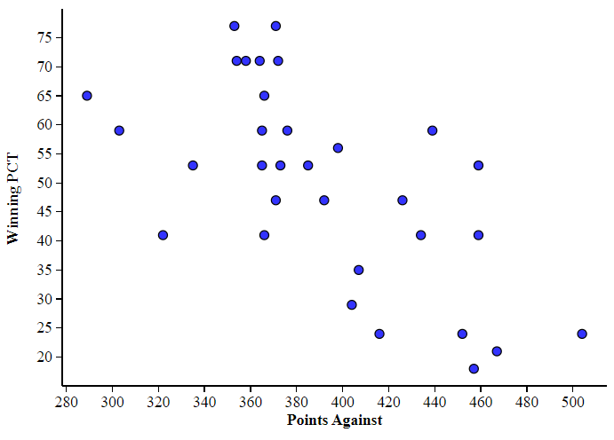
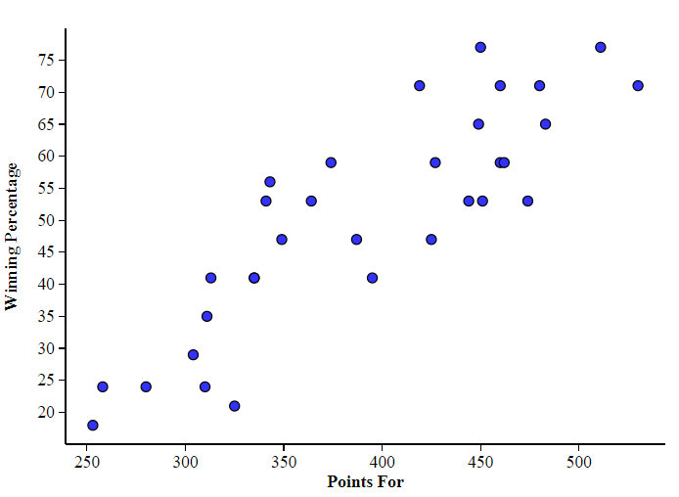

2. On stapplet.com, select the Multiple Regression applet. Input PF as the first explanatory variable, PA as the second explanatory variable, and PCT as the response variable. Be sure that the only box selected with “included in model” is PF. Write the equation of the LSRL using PF and record the value of R² and S.
LSRL: ___________________________________________________________ R²: __________ S: _________
3. Using the LSRL, calculate the residual for the San Francisco 49ers, with 427 points for (PF) and a winning percentage (PCT) of 59 percent.

4. Go to “edit inputs” and deselect the box next to PF; select the box next to PA (now only PA is “included in model”). Write the equation of the LSRL using PA and state the value of R² and S.
LSRL: ___________________________________________________________ R²: __________ S: _________
5. Using this new LSRL, calculate the residual for the San Francisco 49ers, with 365 points against (PA) and a winning percentage (PCT) of 59 percent.

Rather than using just one explanatory variable at a time, what if we used both PF and PA in the same model? Would this improve our predictions? Select “Edit inputs” and click both PF and PA to be included in the model. Begin analysis!

Predictor | Coef | SE Coef | T | P
Constant |  | 20.618 | 0.799 | 0.431
PF |  | 0.023 | 7.002 | <0.001
PA |  | 0.036 | -2.159 | 0.039
6. You should see regression output like the table to the right. Fill in the coefficient boxes, and write the equation of the multiple regression model, in the form:

Predicted PCT = Constant + (coef) PF + (coef) PA

7. Using this new multiple regression model, calculate the residual for the 49ers, with a winning percentage 59 percent, 427 points for, and 365 points against.

8. What was the value of R² and S for this multiple regression model? R²: ________ S: _________

9. Which of the three models did the best at predicting winning percentage among these NFL teams? Explain.

10. What is a variable that may increase the value of R² in our model? Why do you think so?

11. What is a variable that would not increase the value of R² in our model? Why do you think so?

Multiple Regression
QuickNotes

Check Your Understanding

Here is a multiple regression model for predicting y = long jump distance (in inches) using x₁ = 40-yard dash time (in seconds) and x₂ = grade level (input 1 for junior or senior; input 0 for freshmen or sophomore) for a sample of students:

$$\hat{y}=293.56-31.05x_{1}+42.02x_{2}$$

- Predict the long-jump distance for a senior student who had a dash time of 5.41 seconds.

- The student in part (a) had a long jump distance of 171 inches. Calculate and interpret the residual.

