**What Happens When the 10%**

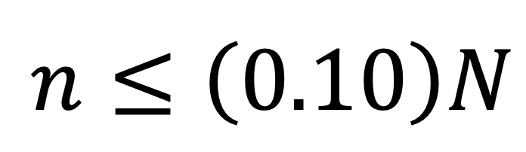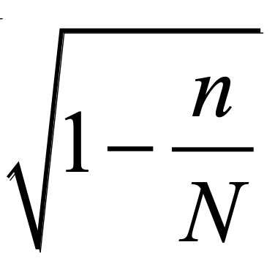

**Condition Isn’t Satisfied?**

The principal of a school wants to estimate the proportion of students at her school that have internet access at home. To do this, she will select a random sample of students, calculate the proportion of students in the sample with internet access at home, and use this proportion to create a 95% confidence interval. Suppose that 800 of the 1000 students in the school have internet access at home.

1. Launch the [*Simulating Confidence Intervals for a Population Parameter*](https://www.rossmanchance.com/applets/2021/confsim/ConfSim.html) applet at [www.rossmanchance.com/applets](http://www.rossmanchance.com/applets).

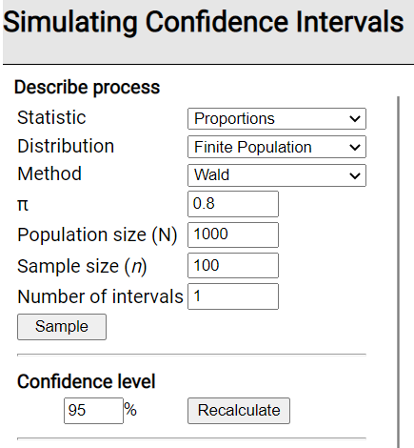

1. Change the Distribution to “Finite Population” and change π (the population proportion) to 0.80, keeping everything else the same. This tells the applet to select a random sample of *n* = 100 students from a population of *N* = 1000 students, where 800/1000 = 0.80 have internet access at home and then construct a 95% confidence interval for *p* using the method taught in AP Statistics (which is sometimes called the Wald method, named for Abraham Wald).
2. Click the Sample button once and notice what happens.
3. What do the blue bars in the upper-right represent?
4. What does the green/red rectangle in the lower-right represent?

(c) Does the confidence interval from this sample capture π = 0.80? How do you know? Click the Sample button a few more times to confirm your description.

1. Change the Number of intervals to 50 and click the Sample button many times. What percent of the intervals captured the population proportion of π = 0.80? How does this compare with the stated confidence level of 95%?

In Steps 2–4, both the Random and Large Counts conditions are met. The applet selects a random sample of students and both *np* = 100(0.80) = 80 and *n*(1 – *p*) = 100(1 – 0.80) = 20 are at least 10. However, we are on the boundary for the 10% condition, as *n* = 100 is exactly 10% of *N* = 1000. To understand why we check the 10% condition, let’s violate it and see what happens.

1. In the applet, change the sample size to *n* = 300 (30% of the population!) and click the Sample button. What do you notice about the length of the intervals compared to when *n* = 100? Why does this make sense?
2. Click the Sample button many times. What percent of the intervals captured the population proportion of π = 0.80? How does this compare with the stated confidence level of 95%?
3. Now change the sample size to *n* = 1000 (100% of the population!). Before doing anything else, what percent of the intervals do you think will capture π = 0.80? Explain your answer.
4. Click the Sample button many times. Was your answer in Step 7 correct?
5. Based on your answers in Steps 5–8, what is the result of violating the 10% condition? Is this a big deal?

**OPTIONAL EXTENSION:** In courses beyond AP Statistics, a “correction” factor can be used to account for sampling without replacement, eliminating the need for the 10% condition. This is called the finite population correction factor = .



1. In the Method menu, change from Wald to Finite correction. What happened to the length of the intervals? Why does it make sense that the margin of error = 0 when *n* = *N* = 1000?
2. Change the sample size back to *n* = 300. Click the Sample button many times. What percent of the intervals captured the population proportion of π = 0.80? How does this compare with your answer in Step 6? With the stated confidence level of 95%?
3. Change the Method back to Wald (our method in AP Stats) and describe what happens to the length of the intervals.
4. Although more complicated to calculate, what are some benefits of using the finite correction?