Practice Question 3: Modeling a Periodic Context


Note: Figure not drawn to scale.

3. To strengthen his muscles, Drew performs dumbbell curls, where he raises and lowers a dumbbell by bending at his elbow. When his arm is extended at his side, the middle of the dumbbell is 33 inches from the ground. The length from Drew’s elbow to his palm where he is gripping the middle of the dumbbell is 11 inches. Drew begins with his right hand extended at his side, then completes one full curl in 4 seconds. A full curl consists of raising and lowering the dumbbell. He continues performing curls in this pattern for a minute.

The sinusoidal function $h$ models the distance between the middle of the dumbbell in Drew’s right hand and the ground, in inches, as a function of time $t$ in seconds.

(A) | The graph of $h$ and its dashed midline for two full cycles is shown. Five points, $G, H, J, K,$ and $L$ are labeled on the graph. No scale is indicated, and no axes are presented.  Determine possible coordinates $\left(t, h\left(t\right)\right)$ for the five points $G, H, J, K,$ and $L$.  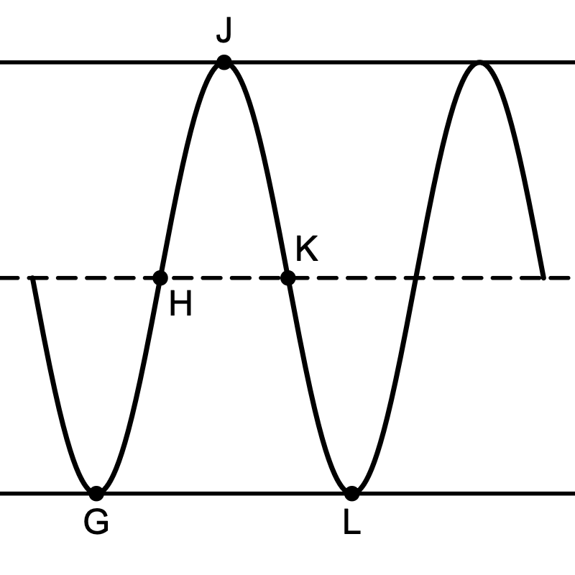
(B) | The function $h$ can be written in the form $h\left(t\right)=\operatorname{acos}\left(b\left(t+c\right)\right)+d$. Find the values of $a, b, c,$ and $d$.
(C) | Refer to the graph of $h$ in part (A). The $t$-coordinate of $H$ is $t_{1}$ and the $t$-coordinate of $J$ is $t_{2}$.
 | (i) | On the interval $(t_{1}, t_{2})$, which of the following is true about $h$?  - $h$ is positive and increasing.  - $h$ is positive and decreasing.  - $h$ is negative and increasing.  - $h$ is negative and decreasing.
 | (ii) | Describe how the rate of change of $h$ is changing on the interval $(t_{1}, t_{2})$.

