**Lesson 5.3 Intro: Does Mrs. Gallas choke under pressure?**

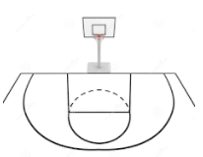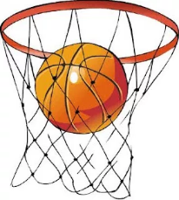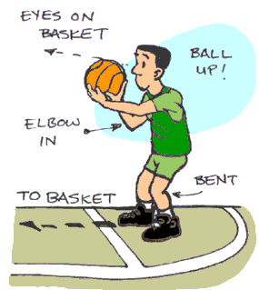

In basketball, it is most common that a player shoots two consecutive free throws. Often basketball announcers will talk about how added pressure makes it more difficult to make the second shot if you miss the first shot. Mrs. Gallas thinks she is pretty good under pressure. Do her free throw stats support this? The table below shows how Mrs. Gallas performed on her second free throw shot when she was shooting two consecutive free throws.

|  |  |  |  |
| --- | --- | --- | --- |
|  |  | Second Shot | |
|  |  | Make | Miss |
| First Shot | Make | 18 | 8 |
| Miss | 3 | 5 |

1. What percentage of the second shot free throws did she make? Show your work.
2. If Mrs. Gallas makes her first shot, what is the probability that she makes the second shot?
3. If Mrs. Gallas misses her first shot, what is the probability that she makes the second shot?
4. As mentioned, it is thought to be harder to make the second shot if you miss the first shot due to added pressure. Do you think Mrs. Gallas is affected by the pressure? Explain thoroughly.