Problem Set A
The crop yield of a hectare of land (10,000 square meters) depends on the amount of fertilizer applied. The table below gives data about the amount of fertilizer applied (in hundreds of kilograms per hectare) and the crop yield (in tons per hectare).

Fertilizer applied  (hundreds of kg/hectare) | Crop yield  (tons per hectare)
0 | 1
0.5 | 2
1 | 4
1.5 | 6
2 | 7
2.5 | 7.5
3 | 7.7
3.5 | 7.8
4 | 7.85
4.5 | 7.88
5 | 7.9

A cubic regression is used to model this data.

- Identify the independent and dependent variable. Enter the data into your calculator.

- Find the cubic regression model where $x$ is the amount of fertilizer applied and $y$ is the predicted crop yield.

- What does the model predict will be the crop yield when 3500 kilograms of fertilizer are applied?

- Calculate the residual for $x=3.5$. Does the model give an overestimate or an underestimate for the true crop yield when 3500 kilograms of fertilizer are applied? Write a sentence to explain.
Problem Set B
To study the relationship between a city’s size (in square miles) and a city’s population density (number of people per square mile), data was collected for 15 randomly selected U.S. cities. The data is shown in the table below. A scatterplot is also given.
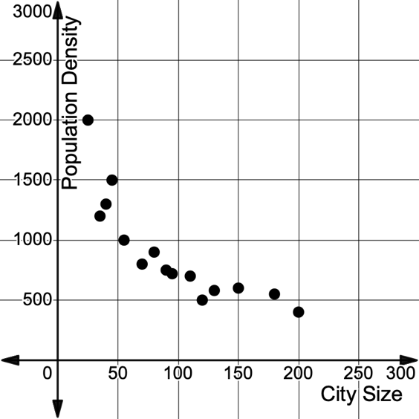
City Size  (square miles) | Population Density  (people per square mile)
45 | 1500
70 | 800
25 | 2000
120 | 500
80 | 900
200 | 400
35 | 1200
150 | 600
90 | 750
180 | 550
110 | 700
55 | 1000
40 | 1300
95 | 720
130 | 580

- Explain why a logarithmic model would be appropriate to model this relationship. Enter the data into your calculator.

- Find the logarithmic regression model, where $x$ is the city size, and $y$ is the population density.

- What is the population density, to the nearest person, predicted by the logarithmic model for a city of 200 square miles?

- Calculate the residual for the city of 200 square miles. Does the model give an overestimate or an underestimate for the true population density for a city of size 200 square miles? Write a sentence to explain.

Problem Set C
After a pollutant is released in a natural environment, it undergoes a process of degradation and decomposition, causing the concentration of the pollutant to decrease over time. This decay can be modeled by an exponential function. The table provides data for the pollutant concentration (in parts per million, ppm) in a body of water in the seven days following a pollution incident.

Days | Pollutant Concentration (ppm)
0 | 10
1 | 8.5
2 | 7
3 | 5.5
4 | 4
5 | 3
6 | 2.5
7 | 2

- Identify the independent and dependent variable. Enter the data into your calculator.

- Find an exponential regression model for this data, where $x$ is the number of days since the pollution incident, and $y$ is the pollution concentration.

- What does the model predict will be the pollutant concentration after 3 days?

- Calculate the residual for $x=3$. Does the model give an overestimate or an underestimate for the true pollutant concentration after 3 days? Write a sentence to explain.

Problem Set D
Traffic patterns are heavily influenced by the time of day. The Federal Highway Administration collects data on the Annual Average Daily Truck Traffic (AADTT) for a particular stretch of road. Selections of this data are displayed in the table below. The input variable represents the $x$th hour of the day ($x=1$ represents the first hour of the day, between 12:00 AM and 1:00 AM, $x=2$ represents the second hour of the day, between 1:00 AM and 2:00 AM, etc.). The output variable, $y,$ is the number of trucks that cross a certain stretch of road in that hour, known as the Hourly AADTT. Truck traffic is monitored and collected over one whole year and then averaged to create the values given in the table.
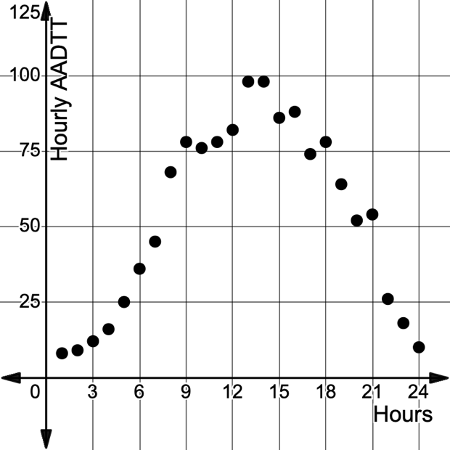
$$x$$ | $$y$$
1 | 8
3 | 12
4 | 16
5 | 25
8 | 68
10 | 76
11 | 78
13 | 98
15 | 86
18 | 78
20 | 52
21 | 54
24 | 10

- Explain why a sinusoidal model would be appropriate to model this relationship. Then enter the data into your calculator.

- Find the sinusoidal regression model where $x$ is the hour of the day and $y$ is the hourly AADTT.

- What is the hourly AADTT, to the nearest truck, predicted by the sinusoidal model for the time between 8 PM and 9 PM?

- Calculate the residual for the value found in part b. Does the model give an overestimate or an underestimate for the true hourly AADTT between 8 PM and 9 PM? Write a sentence to explain.

