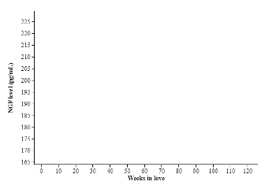  
  
1. Use your calculator to create a scatterplot showing the relationship between *Weeks in love*   
and *NGF level*. Sketch the   
plot below.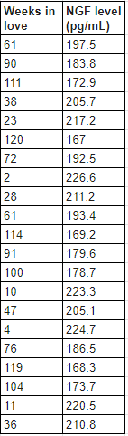

2. Describe the relationship shown in the scatterplot.

3. Write the regression equation for predicting *NGF level* from the number of *Weeks in love*.

4. Find and interpret it in context.

5. Create a residual plot and sketch it below. What does this tell you about the relationship?