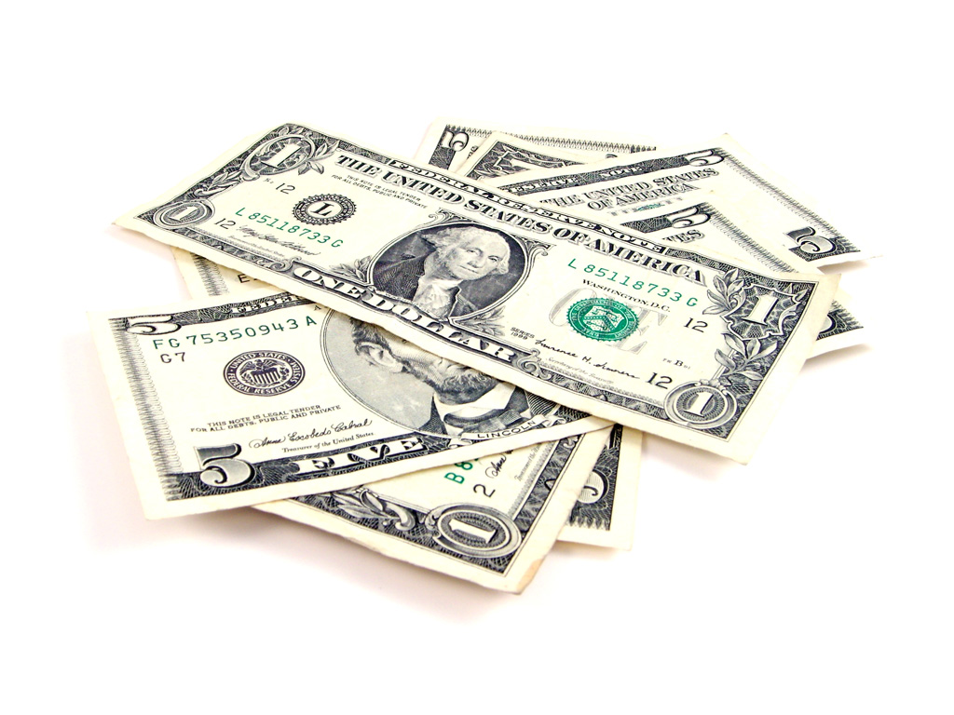
Is It Time For a Raise?
The employees have been working very hard and it’s time to give them a raise. The boss is trying to decide if she should give everyone a $10 raise (add $10 per hour) or double everyone’s wage (multiply by 2).

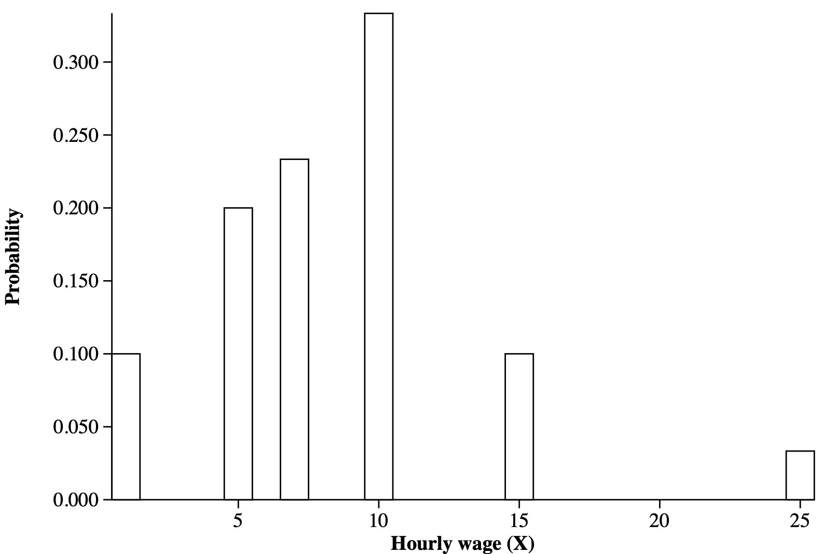
- Copy the probability distribution from the previous lesson below. Graph, then use technology to find the mean and standard deviation.

X | 1 | 5 | 7 | 10 | 15 | 25
Probability

Mean: Standard Deviation:

- To make a decision about what raise should be given, complete the tables and graphs below and calculate the new mean and standard deviation using technology.

- Option 1: Add $10 per hour to the old wage for all employees
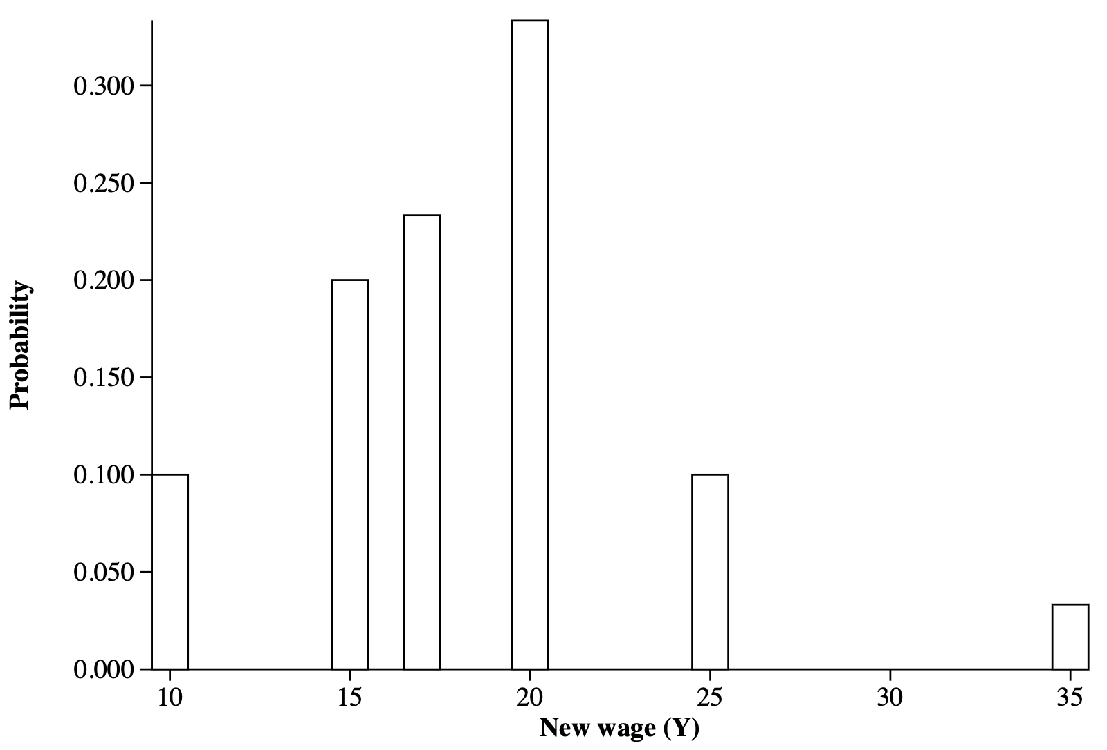

X = Old Wage | 1 | 5 | 7 | 10 | 15 | 25
Y = New Wage
Probability

Mean: Standard Deviation:

How did adding a constant affect the mean and standard deviation?

- Option 2: Double the old wage for all employees
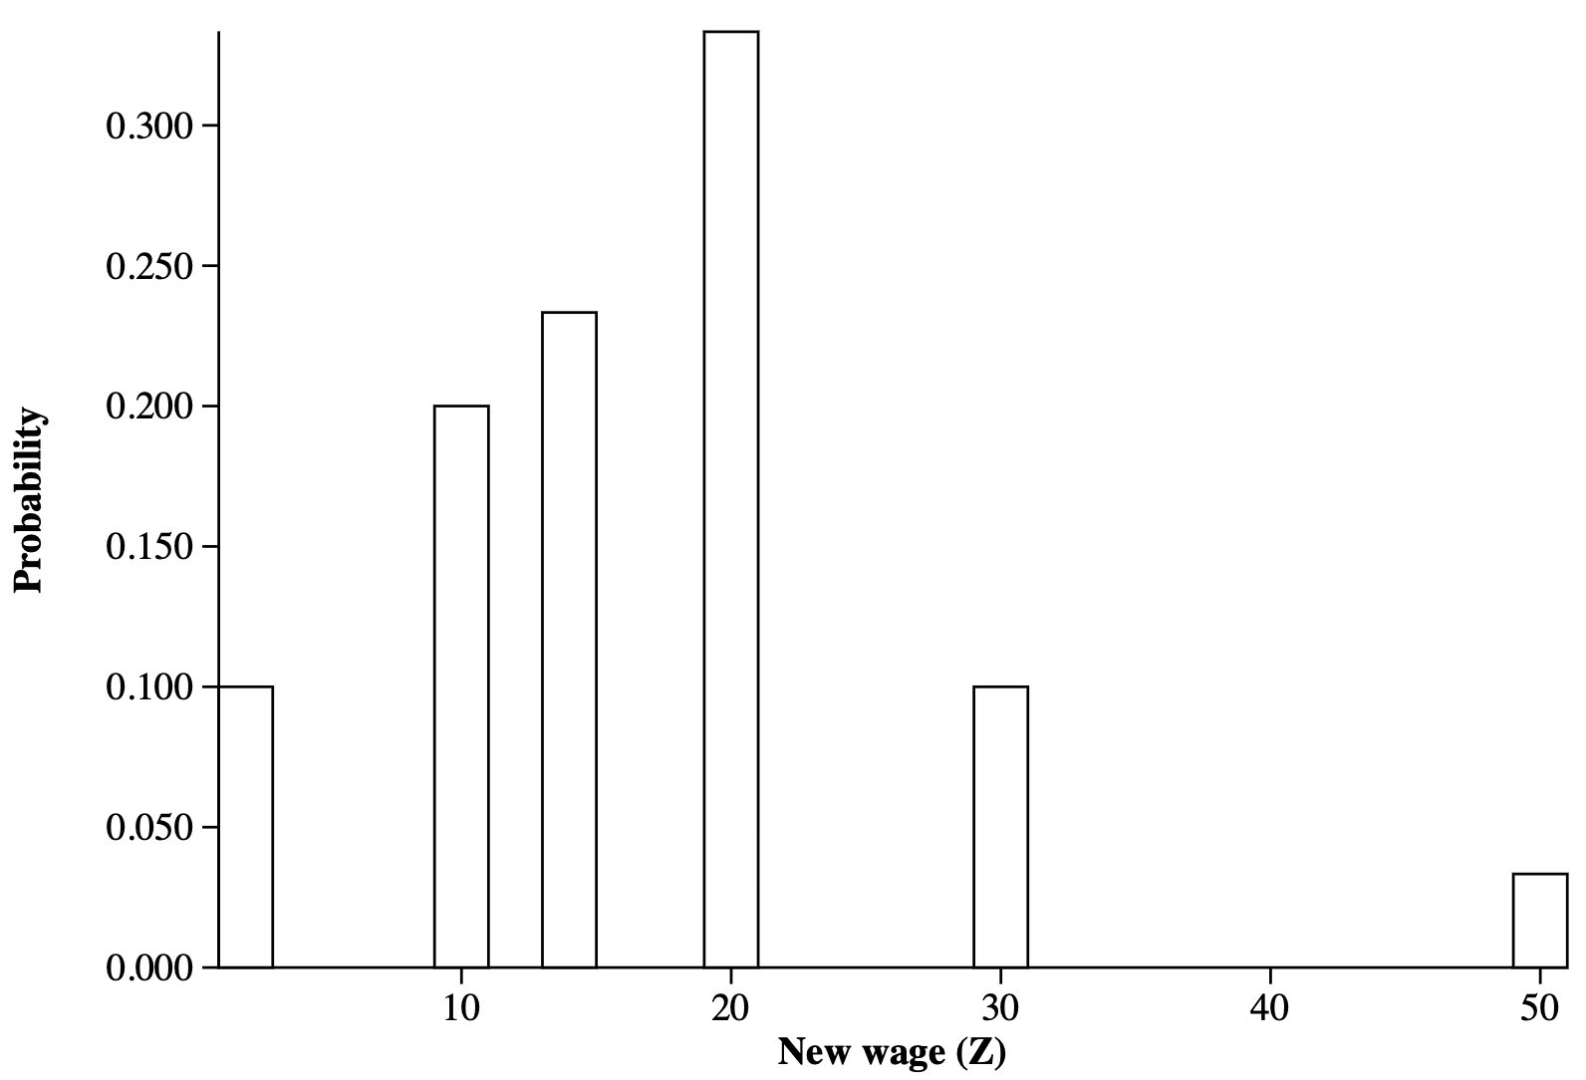

X = Old Wage | 1 | 5 | 7 | 10 | 15 | 25
Z = New Wage
Probability

Mean: Standard Deviation:

How did multiplying by a constant affect the mean and standard
deviation?

- Which option would you prefer? Why?

Lesson 6.3 – Transforming Random Variables
QuickNotes

Check Your Understanding

Let X = the number billionaires in a randomly selected state. Based on current records, the probability distribution of X is as follows:
Number of Billionaires | 0 | 1 | 2 | 3 | 4 | 5 | 6 | 8 | 9 | 10 | 11 | 12 | 13 | 17 | 56 | 58 | 118 | 165
Probability | 0.10 | 0.24 | 0.06 | 0.06 | 0.04 | 0.08 | 0.04 | 0.04 | 0.06 | 0.08 | 0.02 | 0.02 | 0.02 | 0.06 | 0.02 | 0.02 | 0.02 | 0.02

The random variable X has mean $μ_{x}=$ 12.68 and standard deviation $σ_{x}=$ 29.02. Suppose a law is passed requiring each billionaire to pay a $7,000 tax to their state. Let Y = the tax money received by a randomly selected state.

- For a state that has 9 billionaires (X = 9), how much tax money (Y) would they receive?

- Consider the graph of the probability distribution of X and a separate graph of the probability distribution of Y. How would their shapes compare?

- Find the mean and standard deviation of Y.

- Each state agrees to invest $20,000 of the tax money they receive to improve roads. Therefore, the net amount (N) of money a randomly selected state has left to spend is N = Y – $20,000. Describe the shape, mean, and standard deviation of the probability distribution of N.

