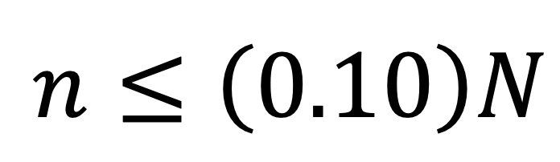
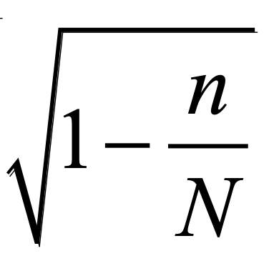
What Happens When the 10%
Condition Isn’t Satisfied?
The principal of a school wants to estimate the proportion of students at her school that have internet access at home. To do this, she will select a random sample of students, calculate the proportion of students in the sample with internet access at home, and use this proportion to create a 95% confidence interval. Suppose that 800 of the 1000 students in the school have internet access at home.

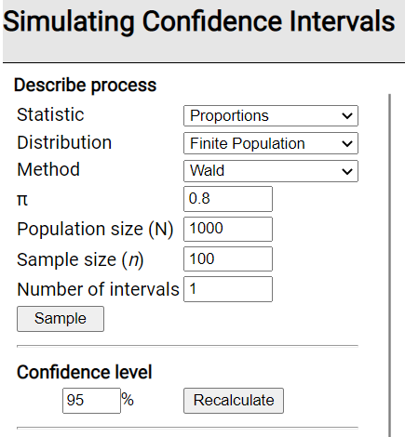
- Launch the Simulating Confidence Intervals for a Population Parameter applet at www.rossmanchance.com/applets.

- Change the Distribution to “Finite Population” and change π (the population proportion) to 0.80, keeping everything else the same. This tells the applet to select a random sample of n = 100 students from a population of N = 1000 students, where 800/1000 = 0.80 have internet access at home and then construct a 95% confidence interval for p using the method taught in AP Statistics (which is sometimes called the Wald method, named for Abraham Wald).

- Click the Sample button once and notice what happens.

- What do the blue bars in the upper-right represent?

- What does the green/red rectangle in the lower-right represent?

(c) Does the confidence interval from this sample capture π = 0.80? How do you know? Click the Sample button a few more times to confirm your description.

- Change the Number of intervals to 50 and click the Sample button many times. What percent of the intervals captured the population proportion of π = 0.80? How does this compare with the stated confidence level of 95%?

In Steps 2–4, both the Random and Large Counts conditions are met. The applet selects a random sample of students and both np = 100(0.80) = 80 and n(1 – p) = 100(1 – 0.80) = 20 are at least 10. However, we are on the boundary for the 10% condition, as n = 100 is exactly 10% of N = 1000. To understand why we check the 10% condition, let’s violate it and see what happens.

- In the applet, change the sample size to n = 300 (30% of the population!) and click the Sample button. What do you notice about the length of the intervals compared to when n = 100? Why does this make sense?

- Click the Sample button many times. What percent of the intervals captured the population proportion of π = 0.80? How does this compare with the stated confidence level of 95%?

- Now change the sample size to n = 1000 (100% of the population!). Before doing anything else, what percent of the intervals do you think will capture π = 0.80? Explain your answer.

- Click the Sample button many times. Was your answer in Step 7 correct?

- Based on your answers in Steps 5–8, what is the result of violating the 10% condition? Is this a big deal?


OPTIONAL EXTENSION: In courses beyond AP Statistics, a “correction” factor can be used to account for sampling without replacement, eliminating the need for the 10% condition. This is called the finite population correction factor = .

- In the Method menu, change from Wald to Finite correction. What happened to the length of the intervals? Why does it make sense that the margin of error = 0 when n = N = 1000?

- Change the sample size back to n = 300. Click the Sample button many times. What percent of the intervals captured the population proportion of π = 0.80? How does this compare with your answer in Step 6? With the stated confidence level of 95%?

- Change the Method back to Wald (our method in AP Stats) and describe what happens to the length of the intervals.

- Although more complicated to calculate, what are some benefits of using the finite correction?

