

How Close Can You Get to the Finish Line?
The Goal: Get your team’s car to reach the finish line without going over.
The Catch: The distance will not be revealed until later.

Test drive your car for pull-backs of 2, 4, 6, and 8 inches. Measure the distance the car travels. Repeat this process 3 times. Fill in the table below.

x = Pull-back Distance (in.) | 2 | 2 | 2 | 4 | 4 | 4 | 6 | 6 | 6 | 8 | 8 | 8
y = Distance Traveled (in.)

Use the applet at statsmedic.com/applets to create three different regression models for the data For each of the three models below:
- Sketch a scatterplot.
- Find the equation for the line of best fit, the correlation (r), and r².
- Sketch the residual plot.

Model 1: Plot (x, y):
- b. Equation: c.

Residual
r:

r²:

Model 2: Plot (x², y):
- b. Equation: c.

Residual
r:

r²:

Model 3: Plot (x, log y)
- b. Equation: c.

Residual
r:

r²:

- Which model is the best choice for your data? Why?

- Calculate how many inches you will have to pull back for a finish line of 80 inches.
Lesson 3.7 – Choosing the Best Regression
QuickNotes
Check Your Understanding
Gapminder.org is an organization dedicated to studying global health. Here is a scatterplot showing average annual income (in thousands of U.S. dollars) and life expectancy (years) for a random sample of 15 countries selected from the Gapminder data base.

The output shows three possible models for predicting life expectancy from income. Model (a) is based on the original data, while Model (b) and (c) involve transformations of the original data. Each set of output includes a scatterplot with a least-squares regression line added and a residual plot. The regression equations are given below.

Model (a) | Model (b) | Model (c)
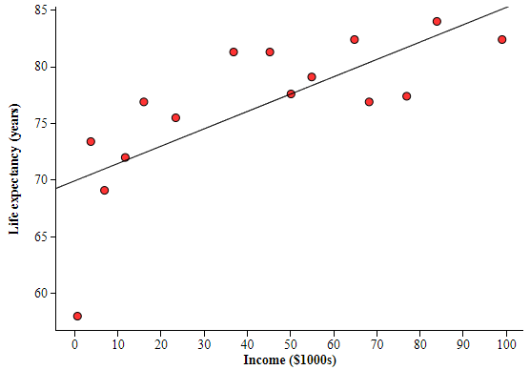 | 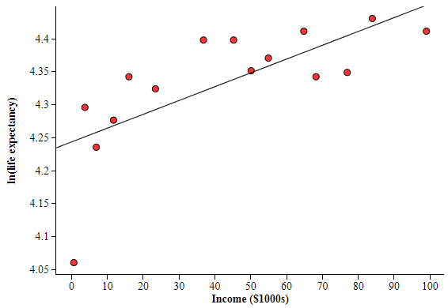 | 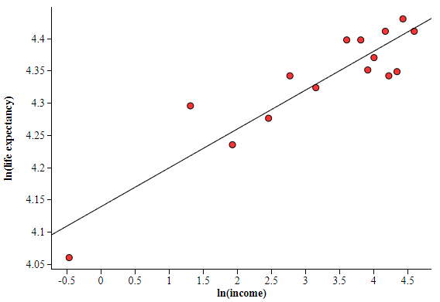
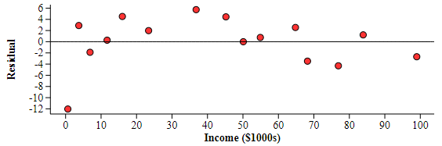 | 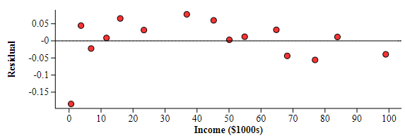 | 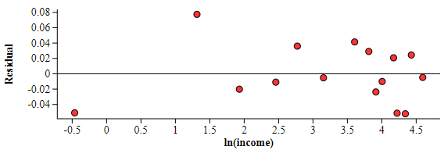
$$\hat{life expectancy}$$  $=69.9352+0.1530(income)$ | $$\hat{\ln\left(life expectancy\right)}$$  $$=4.2436+0.0021\left(income\right)$$ | $$\hat{\ln\left(life expectancy\right)}$$  $$=4.1393+0.0603ln\left(income\right)$$

1. Use each model to predict the life expectancy of residents of a country for which the average annual income is $80,000.

2. Which model will make the best predictions for life expectancy? Explain your answer.

