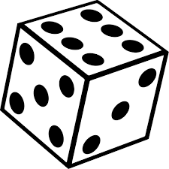
+ Does X + X = 2X? 2 *

- Write out all 36 possible outcomes for two die rolls.

Let X = value of a single die roll. Let X + X = sum of two die rolls.

2. Create a probability distribution for the sum of X + X.

Value | 2 | 3 | 4 | 5 | 6 | 7 | 8 | 9 | 10 | 11 | 12
Probability

3. Use the Discrete Random Variables applet at www.stapplet.com or your calculator.

Mean (X + X) = Interpret:

SD (X + X) = Interpret:

Let X = value of a single die roll. Let 2X = doubling a single die roll.

4. Create a probability distribution for 2X.

Value
Probability

Mean (2X) = Interpret:

SD (2X) = Interpret:

5. Does X + X = 2X? Explain.

6. If you were told you would win the number of dollars of your score, would you rather get the sum of rolling two dice, or doubling a single die roll? Explain.

