$$x$$ | $$h(x)$$ | $$h'(x)$$ | $$h''(x)$$
-3 | 2 | -1 | 0.5
-1 | 8 | 0 | -3
1 | 5 | 1/2 | 4
2 | 4 | 3 | 1
3 | 5 | -4 | 1/3
5 | -5 | -1 | 3
8 | 14 | -2 | 2
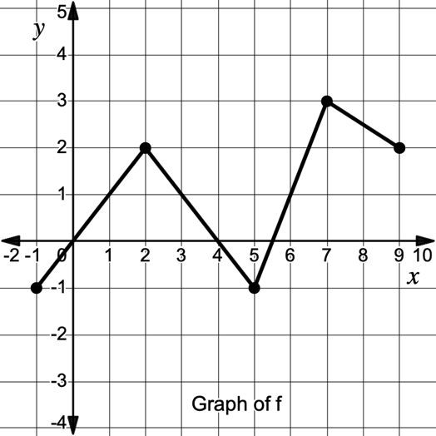
*$h$ is twice differentiable for all real numbers.

$j\left(x\right)={4e}^{3x}-\frac{5}{2}x$ $g\left(x\right)=\left\{\begin{matrix}{3x}^{2}-5x+2 & x≤2 \\ \sqrt{5x+6} & x>2\end{matrix}\right.$

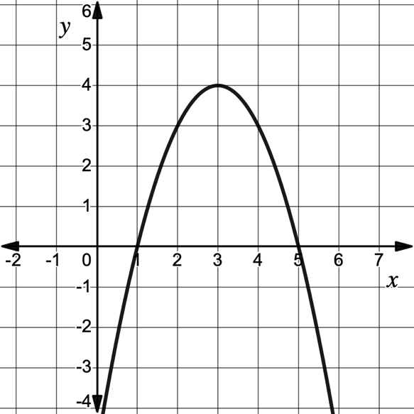
$$y=k(x)$$

L

