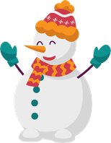
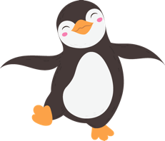

Stats the Halls!
Directions: Solve each question. Your selected answer choice will indicate the color to use for the corresponding regions on the coloring page that match the question number.
- In Frostyville, Alaska, 35% of houses have holiday lights, 20% have a snowman, and 50% have at least one of these. What is the probability that a house has both holiday lights and a snowman?
Answer Choice | Color
(A) 0.05 | Red
(B) 0.10 | Blue
(C) 0.20 | Purple
(D) 0.45 | Dark Green
(E) 0.55 | Yellow

- "The Icy Inferno" ice skating rink offers group or private lessons. Let G be the event that a person signs up for group lessons, and let P be the event that a person signs up for private lessons. Which statement is true?
Answer Choice | Color
(A) If G and P are mutually exclusive, they must be independent. | Red
(B) If G and P are independent, they must be mutually exclusive. | Light Blue
(C) If G and P are not mutually exclusive, they must be independent. | Purple
(D) If G and P are not independent, they must be mutually exclusive. | Green
(E) If G and P are mutually exclusive, they cannot be independent. | Yellow

- A large school of students are going ice skating for a field trip. 60% brought ice skates, while 40% need to rent. Of those with skates, 80% have hockey sticks. Of those renting skates, 10% have hockey sticks. If a randomly selected student has a hockey stick, what is the probability they also have ice skates?
Answer Choice | Color
(A) 0.48 | Red
(B) 0.52 | Dark Blue
(C) 0.80 | Light Purple
(D) 0.92 | Orange
(E) 0.96 | Yellow
- Students are throwing snowballs at a target, but they have terrible aim! Let X be the number of snowballs that hit the target for each student. The probability distribution of X is:
Number of Snowball (X) | 0 | 1 | 2 | 3 | 4 | 5
P(X) | 0.1 | 0.2 | 0.3 | 0.2 | 0.1 | 0.1
What is the probability that a student hits the target at least 3 times?
Answer Choice | Color
(A) 0.2 | Red
(B) 0.3 | Dark Blue
(C) 0.4 | Light Blue
(D) 0.5 | Green
(E) 0.6 | Yellow

- A winter carnival has a ring toss game. It costs $2.00 to play. You have a 10% chance of winning a giant snowman worth $5.00, 20% chance of winning a singing snowman worth $2.50, and 70% of winning a snowman magnet worth $1.00. What is the expected gain or loss if you play?
Answer Choice | Color
(A) Lose $0.10 | Red
(B) Lose $0.30 | Green
(C) Gain $2.00 | Purple
(D) Gain $3.10 | Peach
(E) Gain $3.30 | Yellow

- "Arctic Footwear" makes winter boots in two factories, one run by penguins in Alaska and one run by polar bears in Vermont. Let A be the number of pairs of boots made per day in Alaska (mean = 200, SD = 10). Let V be the number of pairs made in Vermont (mean = 150, SD = 8). Assume A and V are independent. Let T be the total number of pairs of boots produced per day by both factories. What are the mean and SD of T?
Answer Choice | Color
(A) Mean = 200, SD = 18 | Red
(B) Mean = 350, SD = 12.8 | Dark Purple
(C) Mean = 350, SD = 18 | Brown
(D) Mean = 700, SD = 18 | Light Blue
(E) Mean = 700, SD = 12.8 | Yellow
- Pierre the penguin is practicing ice skating jumps. He lands a jump successfully with a probability of 0.6 and the results of each jump can be considered independent. If he attempts 5 jumps, what is the probability that he lands exactly 3 successfully?
Answer Choice | Color
(A) 0.03456 | Peach
(B) 0.1611 | Blue
(C) 0.3456 | Light Purple
(D) 0.3600 | Green
(E) 0.6622 | Yellow

- Bartholomew the polar bear is throwing snowballs. He hits a target with a probability of 0.3 and the results from each throw are independent. If he throws 10 snowballs, what are the mean and standard deviation of the number of times he's expected to hit the target?
Answer Choice | Color
(A) Mean = 3, Standard Deviation = 1.45 | Peach
(B) Mean = 3, Standard Deviation = 2.10 | Blue
(C) Mean = 7, Standard Deviation = 1.45 | Purple
(D) Mean = 7, Standard Deviation = 2.10 | Brown
(E) Mean = 10, Standard Deviation = 2.10 | Yellow

- A factory makes holiday-themed chocolate bars with unusual flavors. 40% are peppermint, while the rest have a variety of flavors, including "snowflake surprise." A customer selects 5 bars at random. What is the probability that at least 3 are peppermint?
Answer Choice | Color
(A) 0.0102 | Red
(B) 0.0640 | Dark Blue
(C) 0.2304 | Purple
(D) 0.3174 | Brown
(E) 0.3456 | Yellow

- A group of penguins are playing "Snowball in the Fish Bucket." Each penguin has a 0.2 probability of getting a snowball in the bucket on any throw and the results of each throw are independent. What is the probability that the first time a penguin gets a snowball in the bucket is on the 4th try?
Answer Choice | Color
(A) 0.0016 | Red
(B) 0.0256 | Orange
(C) 0.1024 | Dark Blue
(D) 0.4096 | Green
(E) 0.8192 | Yellow

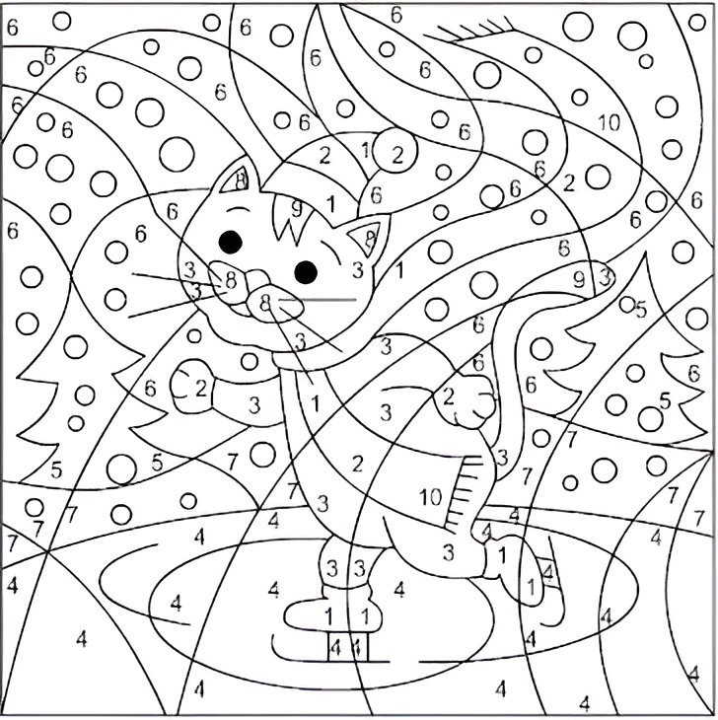
Credit to Nicole Florian (https://coloring-nicole.blogspot.com)

