Thankful for Statistics

|  |
| --- |
| **Directions**: Solve each question. Your selected answer choice will indicate the color to use for the corresponding regions on the coloring page that match the question number. |

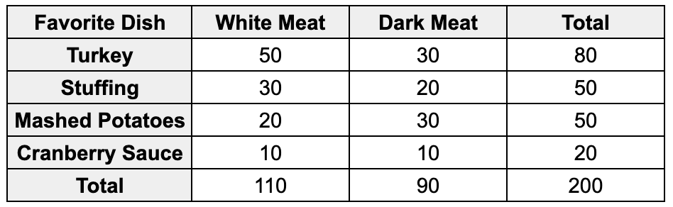

1. A survey of 200 people attending a Thanksgiving dinner asked about their favorite Thanksgiving dish and whether they preferred white meat or dark meat turkey. The results are shown in the table.

What proportion of people who prefer white meat turkey also chose turkey as their favorite dish?

|  |  |
| --- | --- |
| **Answer Choice** | **Color** |
| (A) 0.25 | Red |
| (B) 0.55 | Blue |
| (C) 0.45 | Purple |
| (D) 0.64 | Dark Green |
| (E) 0.80 | Yellow |

|  |  |
| --- | --- |
| **Answer Choice** | **Color** |
| 1. 18 | Pink |
| 1. 20 | Yellow |
| 1. 28 | Blue |
| 1. 30 | Brown |
| 1. 32 | Orange |

1. A local bakery sold a variety of Thanksgiving pies. The distribution of the number of pies sold each day during November is approximately normal with a mean of 24 pies and a standard deviation of 5 pies.

What is the approximate number of pies sold on a day when the sales were at the 79th percentile?

|  |  |
| --- | --- |
| **Answer Choice** | **Color** |
| 1. 0.008 | Light Green |
| 1. 0.092 | Blue |
| 1. 0.488 | Red |
| 1. 0.512 | Orange |
| 1. 0.992 | Brown |

1. A bakery offers three types of Thanksgiving pies: pumpkin, apple, and pecan. 50% of their customers prefer pumpkin pie, 30% prefer apple pie, and 20% prefer pecan pie. If three customers are randomly selected, what is the probability that at least one of them prefers pecan pie?
2. A family tracked the number of pounds of turkey they consumed each Thanksgiving for the past 10 years. The data are shown below:

Pounds of turkey: 12, 15, 14, 18, 16, 20, 15, 17, 19, 18 Mean: 16.4 SD: 2.46

The family realized later that their scale was measuring turkeys as 2 pounds heavier than the true weight and they adjusted each number in the list to account for this error. What is the new mean and standard deviation of the data?

|  |  |
| --- | --- |
| **Answer Choice** | **Color** |
| 1. Mean: 14.4, Standard Deviation: 0.46 | Blue |
| 1. Mean: 14.4, Standard Deviation: 2.46 | Orange |
| 1. Mean: 16.4, Standard Deviation: 0.46 | Yellow |
| 1. Mean: 18.4, Standard Deviation: 0.46 | Pink |
| 1. Mean: 18.4, Standard Deviation: 2.46 | Red |

1. A group of researchers wants to investigate whether eating pumpkin pie on Thanksgiving Day leads to increased feelings of happiness. They recruit 100 volunteers and randomly assign them to one of two groups:

* Group A: Eat a slice of pumpkin pie as part of Thanksgiving dinner.
* Group B: Do not eat any pumpkin pie as part of Thanksgiving dinner.

One hour after dinner, the researchers ask the participants to rate their happiness on a scale of 1 to 10. They found that participants who ate pumpkin pie reported significantly higher levels of happiness.

Which of the following is the most appropriate conclusion?

|  |  |
| --- | --- |
| **Answer Choice** | **Color** |
| 1. Eating pumpkin pie on Thanksgiving Day causes increased feelings of happiness for people like the volunteers in this study. | Dark Green |
| 1. The researchers cannot draw any conclusions because the sample size is too small. | Pink |
| 1. There is no relationship between eating pumpkin pie on Thanksgiving Day and feelings of happiness. | Yellow |
| 1. There is an association between eating pumpkin pie on Thanksgiving Day and increased feelings of happiness, but a cause-and-effect relationship cannot be established. | Black |
| 1. The researchers cannot draw any conclusions because the participants were volunteers. | Red |

1. A graph with blue dots

   Description automatically generatedA group of friends decided to analyze their Thanksgiving cooking data. They recorded the number of pounds of turkey they cooked versus the total cooking time in hours. The data are shown in the scatterplot.

Which of the following best describes the relationship between the weight of the turkey and the cooking time?

|  |  |
| --- | --- |
| **Answer Choice** | **Color** |
| 1. There is a strong, negative, linear relationship between the weight of the turkey and the cooking time. | Black |
| 1. There is a strong, positive, linear relationship between the weight of the turkey and the cooking time. | Light Green |
| 1. There is a weak, negative, linear relationship between the weight of the turkey and the cooking time. | Orange |
| 1. There is a weak, positive, linear relationship between the weight of the turkey and the cooking time. | Brown |
| 1. There is no relationship between the weight of the turkey and the cooking time. | Pink |

1. The boxplots below show the distribution of cooking times (in minutes) for two different types of Thanksgiving pies, Pumpkin and Apple, based on data collected from a group of bakers.

Which of the following statements is NOT true based on the boxplots?

|  |  |
| --- | --- |
| **Answer Choice** | **Color** |
| 1. The median cooking time for apple pie is greater than the median cooking time for Pumpkin pie. | Yellow |
| 1. The interquartile range (IQR) for apple pie is greater than the IQR for pumpkin pie. | Orange |
| 1. The range of cooking times for apple pie is greater than the range of cooking times for pumpkin pie. | Blue |
| 1. More than 25% of the pumpkin pies were cooked for a shorter time than the minimum cooking time for apple pie. | Red |
| 1. The maximum cooking time for pumpkin pie is greater than the maximum cooking time for apple pie. | Black |

|  |  |
| --- | --- |
| **Answer Choice** | **Color** |
| 1. 0.15 | Brown |
| 1. 0.16 | Light Green |
| 1. 0.19 | Orange |
| 1. 0.30 | Purple |
| 1. 0.40 | Yellow |

1. At a Thanksgiving gathering, there is a bowl of 30 assorted candies. 30% of the candies are chocolate, 40% are caramel, and the rest are fruit flavored. If a guest randomly selects two candies from the bowl without replacement, which of the following is closest to the probability that both candies are caramel?

1. A bakery owner wants to gather feedback on her new Thanksgiving-themed cupcakes. She decides to survey a sample of her customers who purchased the cupcakes during the Thanksgiving week. The baker is considering the following methods of sampling:

* Assign a number to each customer on the sales record and use a random number generator to select customers for the survey.
* Divide customers into groups based on the type of cupcake they purchased (e.g., pumpkin spice, cranberry orange, apple cinnamon) and randomly select customers from each group.
* Survey the first 50 customers who come into the bakery on the day after Thanksgiving.
* Select every 10th customer from the list of cupcake sales throughout Thanksgiving week.

Which sampling method is she NOT considering?

|  |  |
| --- | --- |
| **Answer Choice** | **Color** |
| 1. Convenience Sample | Brown |
| 1. Stratified Random Sample | Blue |
| 1. Cluster Sample | Yellow |
| 1. Systematic Sample | Orange |
| 1. Simple Random Sample | Light Green |

1. A bakery collected data on the number of pies they sold each day versus the high temperature for that day. They found a linear relationship and calculated the equation of the least-squares regression line to be:

$\hat{\text{number of pies sold}}$ = 20 + 0.5 * (high temperature)

Which of the following best interprets the slope of the regression line?

|  |  |
| --- | --- |
| **Answer Choice** | **Color** |
| 1. For every 1 degree increase in high temperature, the predicted number of pies sold increases by 20. | Blue |
| 1. For every 1 degree increase in high temperature, the number of pies sold increases by 0.5. | Orange |
| 1. For every 1 degree increase in high temperature, the predicted number of pies sold increases by 0.5. | Pink |
| 1. For every 1 pie increase in the number of pies sold, the high temperature increases by 0.5 degrees. | Purple |
| 1. For every 1 pie increase in the number of pies sold, the predicted high temperature increases by 20 degrees. | Red |

