What’s Going On in This Graph?
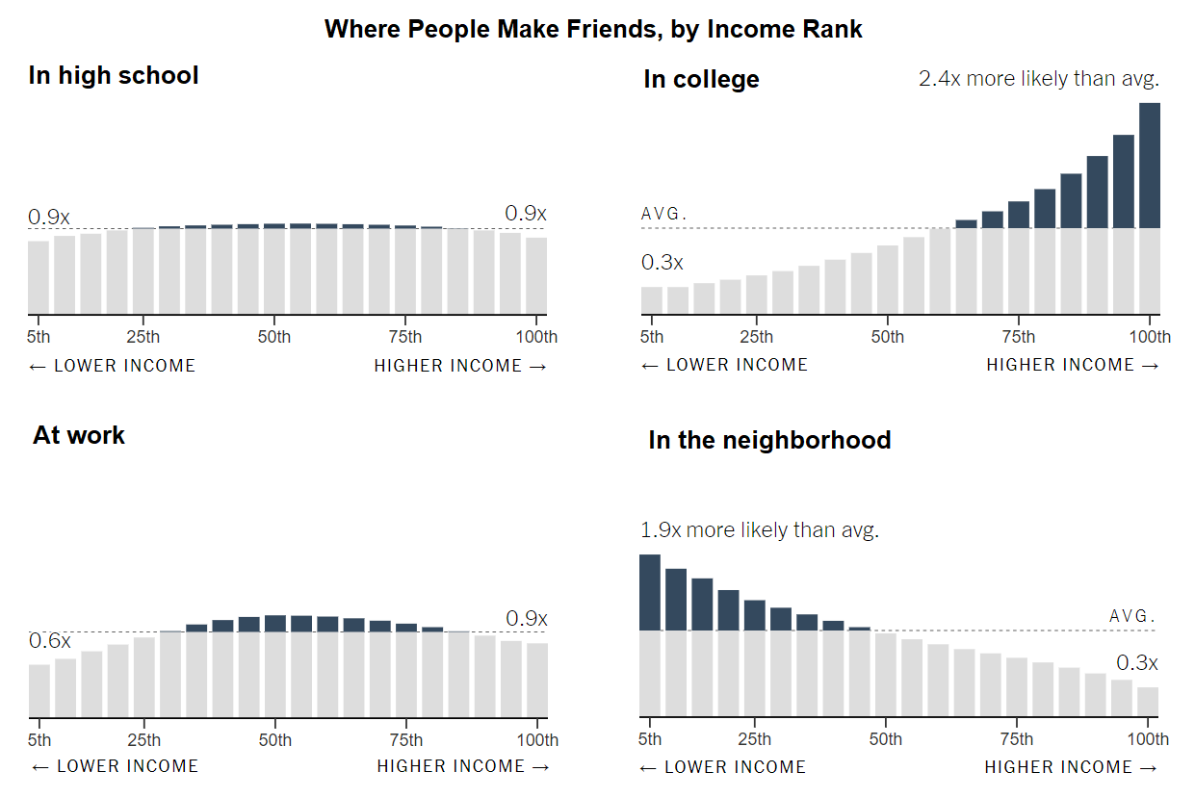

- What do you notice? What do you wonder?

- What impact does this have on you and your community?

- What do you think is going on in this graph? Write a headline that captures the graph’s main idea.


Post your answers at www.tinyurl.com/WGOITG-NYT by clicking on the graph and then the comment button.

