
Thanksgiving Calculus

Directions: Solve each problem and color the corresponding regions on the coloring page based on the answer you got. For example, if you think the answer to question 1 is
$x=10$ only, you would color all regions marked as “1” in dark green.

- For $-4<x<12$, for which values of x does $f(x)$ have a removable discontinuity?

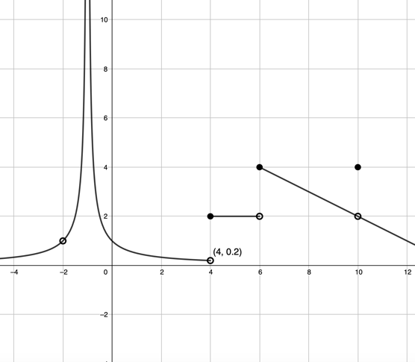
$$f(x)$$

$$x=-2, 4, 6, 10$$  Red | $$x=-1, 4, 6$$  Blue | $$x=-2, 10$$  Purple | $x=10$ only  Dark Green

- Find $\lim_{x→4}{\frac{x^{2}-3x-4}{x^{2}-10x+24}}$

$$-5/2$$  Blue | $$½$$  Yellow | $$0$$  Pink | Does not exist  Brown

- Consider the closed curve in the xy-plane given by $x^{2}+8x+y^{3}-4y=-16$. Find the slope of the line tangent to the curve at $(-2,1).$

20  Purple | 4  Red | 0  Yellow | -4  Pink

- The graph of $g(x)$ is shown. Order the following from least to greatest:
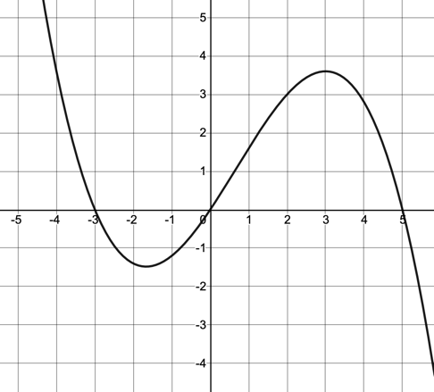
$$g(x)$$
- $\lim_{h→0}{\frac{g\left(3+h\right)-g(3)}{h}}$
- Average rate of change of $g(x)$ on [3,5]
- $g'(5)$
- $\frac{g\left(1\right)-g(-3)}{1-(-3)}$

A, D, B, C  Blue | C, B, A, D  Orange | B, C, A, D  Red | C, A, D, B  Purple

- A particle’s position on the x-axis is given by $x\left(t\right)=\frac{1}{3}t^{3}-\frac{7t^{2}}{2}+10t+4$, where x is measured in meters and t is measured in seconds. For which values of t is the particle speeding up?
$$t=0.5$$  Black | $$t=3$$  Dark green | $$t=4$$  Orange | $$t=5$$  Brown

- Advertisers try to measure the Click-Through Rate (CTR) for their ads, which gives the ratio of people who click on an ad (Total Clicks on Ad) compared to the people who see the ad (Total Impressions). For example, a CTR of 0.05 means that 5% of the people seeing the ad actually click on the ad and follow the link. A company initiates a new marketing strategy in the hope of increasing their CTR score. Let $C(t)$ represent the company’s CTR, t weeks into the initiative. What are the units of $C'(t)$?

$$\frac{clicks}{impression}$$  Red | $$\frac{clicks}{week}$$  Blue | $$\frac{clicks/impression}{week}$$  Light green | $$\frac{clicks}{impression^{2}}$$  Orange
Selected values of $f\left(x\right), g(x)$ and their derivatives are given in the table below. Use the table to answer questions 7-9.

$$x$$ | $$f(x)$$ | $$g(x)$$ | $$f'(x)$$ | $$g'(x)$$
-3 | 8 | 6 | 5 | 1
0 | -1 | 2 | 11 | 9
2 | -3 | 5 | -4 | -12
7 | 4 | 0 | 2 | -6

- If $h\left(x\right)=f(g\left(x\right))$, find $h'(7)$.

-12  Yellow | -66  Black | 11  Blue | -24  Red

- If $k\left(x\right)=f^{-1}(x)$, find $k'(-3)$.

$$-1/4$$  Brown | $$1/5$$  Light Green | 5  Orange | -4  Purple

- If $j\left(x\right)={\left(3f\left(x\right)-1\right)}^{3}$, find $j'(2)$.
507  Black | 300  Pink | -5184  Dark green | -3600  Yellow

- Write the equation of the line tangent to $y=\sin{(2x)}$ at $x=\frac{5π}{6}$.
$$y+\frac{\sqrt{3}}{2}=\frac{1}{2}(x-\frac{5π}{6})$$  Brown | $$y-\frac{1}{2}=\left(x-\frac{5π}{6}\right)$$  Blue | $$y+\frac{\sqrt{3}}{2}=(x-\frac{5π}{6})$$  Pink | $$y-\frac{\sqrt{3}}{2}=\frac{1}{2}(x-\frac{5π}{6})$$  Orange

