Warm Up:

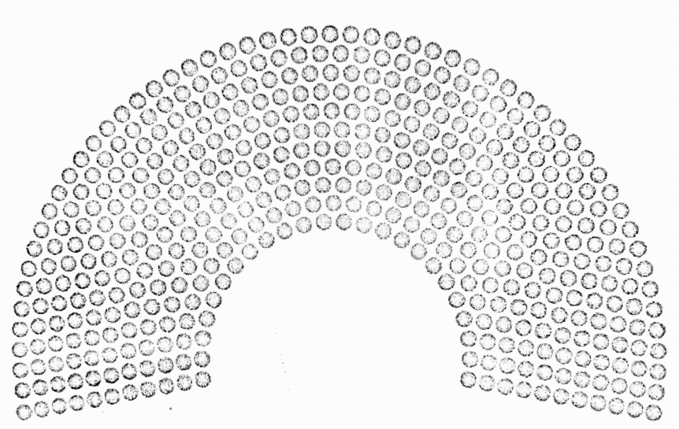

1. The diagram above shows the 435 total seats in the current 116th House of Representatives. Shade the number of seats that you think are filled by female representatives.
2. How many seats did you shade? Discuss your prediction with your group.

Is the House of Representatives *actually* representative?

The current 116th House of Representatives is the most diverse in history. There are 234 Democratic representatives and 200 Republican representatives (ignore the 1 independent). Of the Republican Party representatives, 13 are female. Of the Democratic Party representatives, 93 are female.

Use this information to complete the table below.

|  |  |  |  |
| --- | --- | --- | --- |
|  | Female | Male | Total |
| Republican |  |  |  |
| Democrat |  |  |  |
| Total |  |  |  |

1. How many females are in the House of Representatives? How does this compare to your prediction from the Warm Up?
2. What percent of the representatives are female?
3. What percent of the Democrats are female?
4. What percent of the Republicans are female?
5. What do you notice about your answers to #2 - 4? Why do you think this is?
6. Go to [tinyurl.com/116representation](https://tinyurl.com/116representation) and find the interactive seat map of the 116th House. Spend some time **individually**investigating the subgroups of the House. Write down what you notice.
7. In your **groups**, share your findings. What is noteworthy about the subgroups?
8. As a **group**, choose one subgroup to focus on. What questions do you have about the data describing that subgroup?
9. As a **group**, you will be writing a persuasive essay to support this viewpoint. Choose one of your questions and turn it into an arguable viewpoint. Write it below. When you have come to a consensus, get your idea approved by your teacher.

Arguable viewpoint:

1. Use the graphic organizer provided to plan your essay. The argument must include mathematical support from the source and a display of the data using a graph.