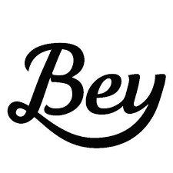Does Beyoncé Write Her Own Lyrics?

icon175x175

icon175x175icon175x175

1. Quickly circle a random sample of 5 words. Write them below. How many letters in each word?
2. What is the average word length of your sample? ________
3. Put your average on the dotplot on the white board at the front of the room. Copy the class dotplot below.



1. Find a new sample of 5 words using a random number generator. Put your average on the dotplot on the white board at the front of the room. Copy the class dotplot below.



1. How is the dotplot from #4 different than the dotplot for #3? Which do you think is a better estimator of the true average word length?
2. What do you think the true average word length is for “Crazy in Love”? ________
3. It is known that Beyonce wrote the lyrics for all the Destiny’s child songs. The average word length for these songs is 3.64 letters. Based on our work today, do we have convincing evidence that Beyonce did not write the lyrics for “Crazy in Love”? Explain.

Lesson 4.1 ­– Simple Random Sample

QuickNotes

Check Your Understanding

1. A sign at a local business says, “Rate us 5-stars on Google and get a $10 gift card!” The store manager uses the ratings to learn how people in the community feel about the business.
2. What type of sample did the manager obtain?
3. Explain why this sampling method is biased.
4. The manager finds that 92% of customers rate the business with 5 stars. Is 92% likely to be greater than or less than the percent of all people in the community who truly believe the business deserves 5-stars?
5. To help reduce bias, the manager decides to survey the next 10 customers that make a purchase.
6. What type of sample did the manager obtain?
7. Explain why this sampling method is biased.
8. How could the manager avoid the bias described in Question 2?