**How many tanks did the Germans produce?**



Today we are going to try to guess the number of tanks that the Germans produced during WW2. To start, we will estimate the total number of popsicle sticks in a bag (N) based on a sample of 7 sticks. The popsicle sticks are numbered in increasing order from 1 to N.

1. Which statistic was your group assigned? (circle one)

2 x median mean + 3 SD maximum

2. Assume there are 100 popsicle sticks in the bag. Use a random number generator to select a random sample of 7 sticks, then calculate the value of your statistic based on that sample. Select a total of 5 samples. Add your values to the dotplot at the front of the room.

Random sample: ___________________________ Statistic: __________

Random sample: ___________________________ Statistic: __________

Random sample: ___________________________ Statistic: __________

Random sample: ___________________________ Statistic: __________

Random sample: ___________________________ Statistic: __________

3. Sketch the dotplots produced for each of the three statistics.



2 x median



mean + 3 SD



maximum

4. Which of the three statistics works the best? Why?

5. Based on what you learned from the three statistics, create a new statistic or modify one of the original three statistics so that it does a better job.

6. Calculate the value of your new statistic for as many samples that time will allow. Then make a dotplot of the values of your statistic.

Random sample: ___________________________ Statistic: __________

Random sample: ___________________________ Statistic: __________

Random sample: ___________________________ Statistic: __________

Random sample: ___________________________ Statistic: __________

Random sample: ___________________________ Statistic: __________



Formula for new statistic: ___________

7. Now your teacher will select a random sample of 7 popsicle sticks from the bag that contains an unknown number of total sticks (N). Record the sample and then calculate your estimate for N using your new statistic.

Random sample: ___________________________ Statistic: __________

8. Write your group members’ names and your estimate for N on an index card and hand in to the teacher. Then the teacher will reveal the truth!

Actual number of popsicle sticks in the bag: ______

Sampling Distributions – Center and Variability

Important Ideas

Check Your Understanding

During World War II, the Allies captured many German tanks. Each tank had a serial number on it. Allied commanders wanted to know how many tanks the Germans had so that they could allocate their forces appropriately. They sent the serial numbers of the captured tanks to a group of statisticians in Washington, D.C., and asked for an estimate of the total number of German tanks *N*. Here are simulated sampling distributions for three statistics that the statisticians considered, using samples of size *n* = 7. The blue line is at *N*, the total number of German tanks. The shorter green line segments mark the mean of each simulated sampling distribution.

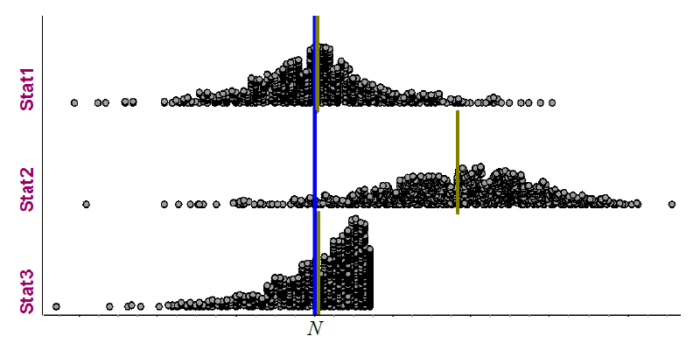

1. Do any of these statistics appear to be unbiased? Justify.
2. Which of these statistics do you think is best? Explain your reasoning.
3. Explain how the Allies could get a more precise estimate of the number of German tanks using the statistic you chose in part 2.