Turkey Trot
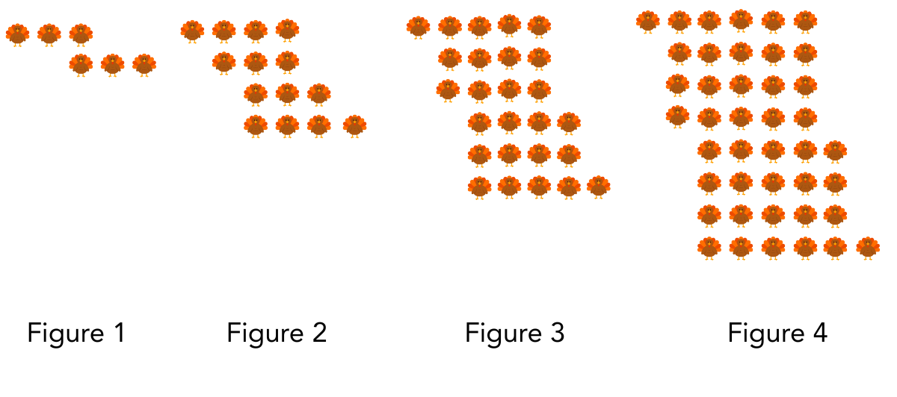

Figures 1-4 of a visual sequence of turkeys are shown.
- How do you see the pattern growing?

- What would Figure 5 look like? Can you determine the number of turkeys in Figure 5 without counting them one by one?

- How many turkeys would be in Figure 10?

- How many turkeys would be in Figure $n$? Show how your expression connects to the visual.

