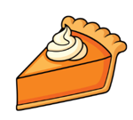
Slice by Slice (Part 1)
Costco offers a 12-inch pumpkin pie for $5.99.

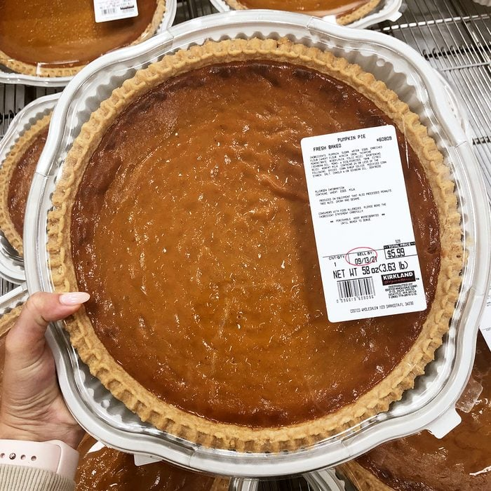
Find the angle made at the tip of a slice of pie that would be worth $1.25. How much would that slice weigh?



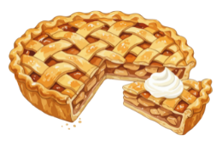
Slice by Slice (Part 2)
At a Thanksgiving gathering, two apple pies are served. One pie has a 12-inch diameter, and one pie has a 9-inch diameter. The larger pie is cut into 10 slices. If you want to cut a slice from the smaller pie so that it has the same area as one slice from the larger pie, what should the central angle of the slice be?

