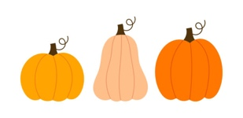
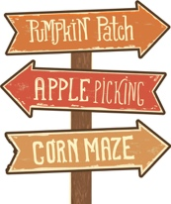
The Pumpkin Sale

At a pumpkin patch, small pumpkins are sold for $3, medium pumpkins are sold for $7, and large pumpkins are sold for $12. Ms. Jones is in charge of the decorations for the town’s fall festival and purchased 16 pumpkins from the pumpkin patch including at least one of each size. She spent a total of $109. How many of each size pumpkin did she buy?

Jamirea says there are two possible answers so there’s no way of knowing for sure how many of each kind Ms. Jones bought. Do you agree or disagree? Explain.

Extension 1: Change only the numbers in the problem and nothing else so that there is exactly one solution. Can you do it by changing the fewest numbers possible?

Extension 2: Change only the numbers in the problem and nothing else so that there are more than two solutions.

