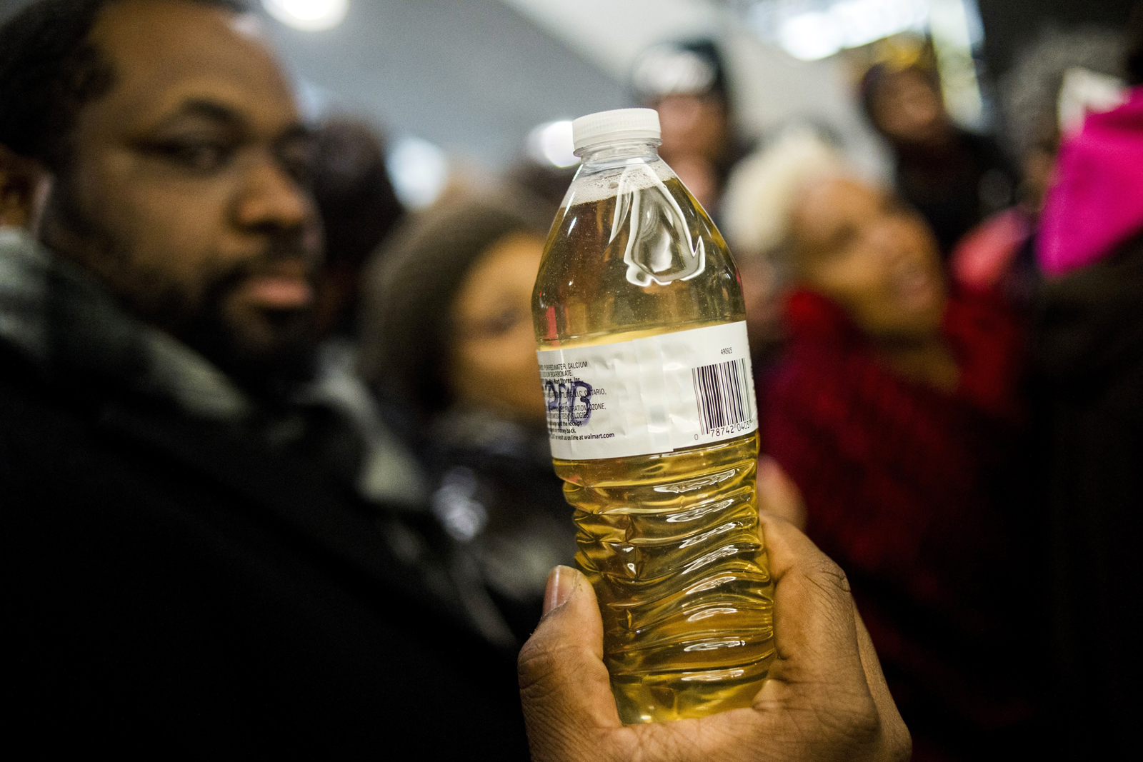

**Testing Flint’s Water**

In 2014, to save money, Flint city officials switched the water supply from the Detroit water system to the Flint River. The following years became a battle in Flint, between residents raising concerns about the safety of their tap water and government officials who insisted it was fine.

Today, we will simulate the investigation of Flint’s water that was performed by outside researchers at Virginia Tech. We will perform a **significance test** to see if there is convincing evidence that the **proportion** of homes in Flint with high-lead content in their water supply passes the EPA threshold for safety.

**Context: Flint Water Crisis**







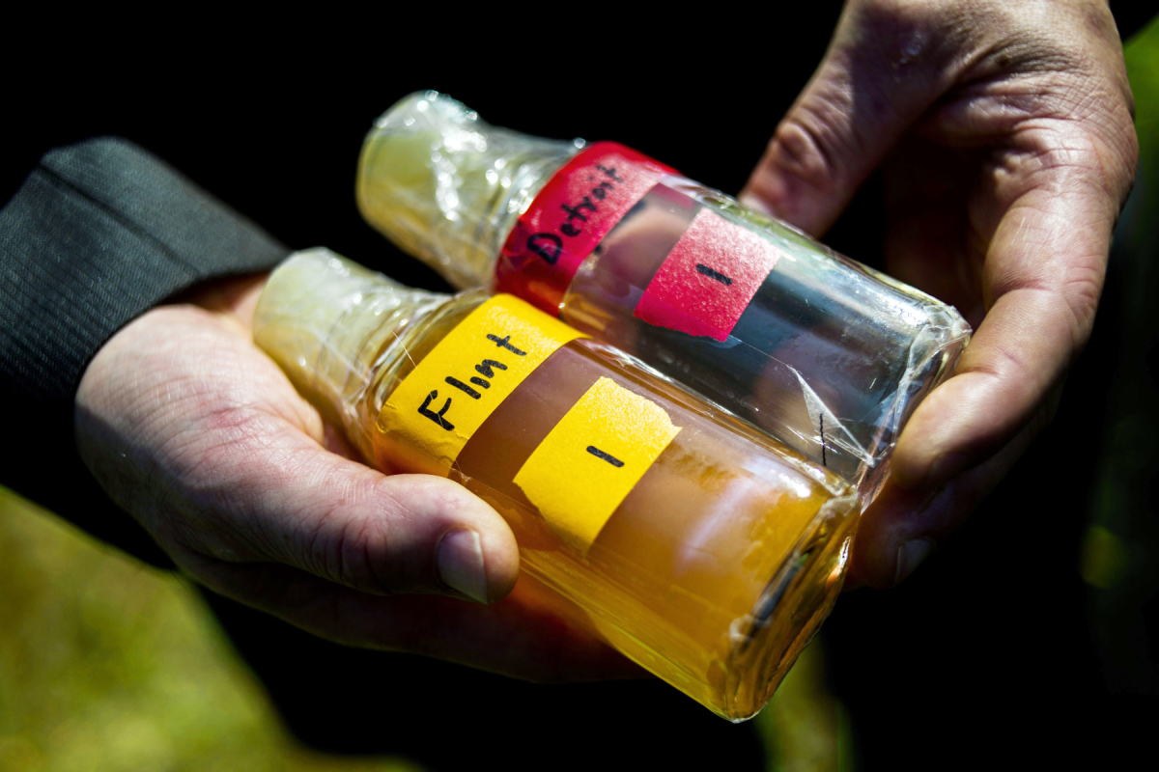

*Samuel Wilson (MLive.com)*

*Jake May (The Flint Journal, AP Images)*

*WNEM Newsroom*

**2014/2015**

Residents voice concerns about declining water quality.

**2014**

Flint city officials celebrate as they cut costs by switching the water supply from Detroit to the Flint River.

**2015**

Mayor drinks tap water on local television to “prove” the water is safe. Outside investigators start testing Flint’s water systems.

**Collect Data:** Use a random number generator to select 5 homes from the population of Flint. For each home, record whether there was a high lead level (>15 parts per billion) or a low lead level (≤15 ppb). Write “H” for a high lead level and “L” for a low lead level.

________ ________ ________ ________ ________

**Class Sample:**

Number of high-lead homes: _________ Number of low-lead homes: ________

1. According to EPA regulations, if more than 10% of homes in a city have high lead content in their water (>15 parts per billion), the city’s water supply is unsafe. Based on the sample your class collected, is there convincing evidence that the water system in Flint is unsafe?

**STATE:** Parameter: Statistic:

Hypotheses: Significance level: 5% ()

**PLAN:** Name of procedure:

Check conditions:

**DO:**  General Formula:

Specific Formula:

Picture (of the Normal curve):

Work:

Test statistic:

P-value:

**CONCLUDE:**

2. A Virginia Tech study** randomly sampled water from 252 homes in Flint. Of those, 42 had high lead content. $\hat{p}=\frac{42}{252}=0.17$. Compared to our class data, does this study give more or less convincing evidence of an unsafe water supply in Flint. Why?

** Edwards, M., et al. Virginia Tech Flint Water Study (published Sept. 2015, accessed July 2020): <http://flintwaterstudy.org/information-for-flint-residents/results-for-citizen-testing-for-lead-300-kits/>

Significance Test for a Proportion - 4 Step

Important ideas:

Check Your Understanding

1. Sometimes parents and grandparents like to recount how difficult life was when they were kids, such as having to walk 10+ miles to school (in the snow, uphill both ways). A random sample of 180 teenagers were selected and 40% had heard stories from their parents or grandparents about how difficult life was when they were kids. Do these data provide convincing evidence at the *α* = 0.05 significance level that the proportion of all teenagers who have heard stories from their parents or grandparents about how difficult life was when they were kids differs from 0.50?

**STATE:** Parameter: Statistic:

Hypotheses: Significance level:

**PLAN:** Name of procedure:

Check conditions:

**DO:** General Formula:

Specific Formula:

Picture: Work:

Test statistic:

*P*-value:

**CONCLUDE:**

1. A 95% confidence interval for the proportion of all teenagers who have heard stories from their parents or grandparents about how difficult life was when they were kids is (0.328, 0.472). Explain how the confidence interval is consistent with, but gives more information than, the test.